**1: LAUNCHING WEKA**

**WEKA 🡪 Waikato Environment for Knowledge Analysis**

The WEKA GUI Chooser provides a starting point for launching WEKA’S main GUI applications and supporting tools. The GUI Chooser consists of four buttons - one for each of the four major Weka applications - and four menus.

The buttons can be used to start the following applications:

1. **Explorer**: An environment for exploring data with WEKA.
2. **Experimenter:** An environment for performing experiments and conducting statistical tests between learning schemes.
3. **Knowledge Flow**: It supports essentially the same functions as the explorer but with a drag and drop interface. One advantage is that it supports incremental learning.
4. **Simple CLI**: Provides a simple command-line interface that allows direct execution of WEKA commands for operating systems that do not provide their own command line interface.

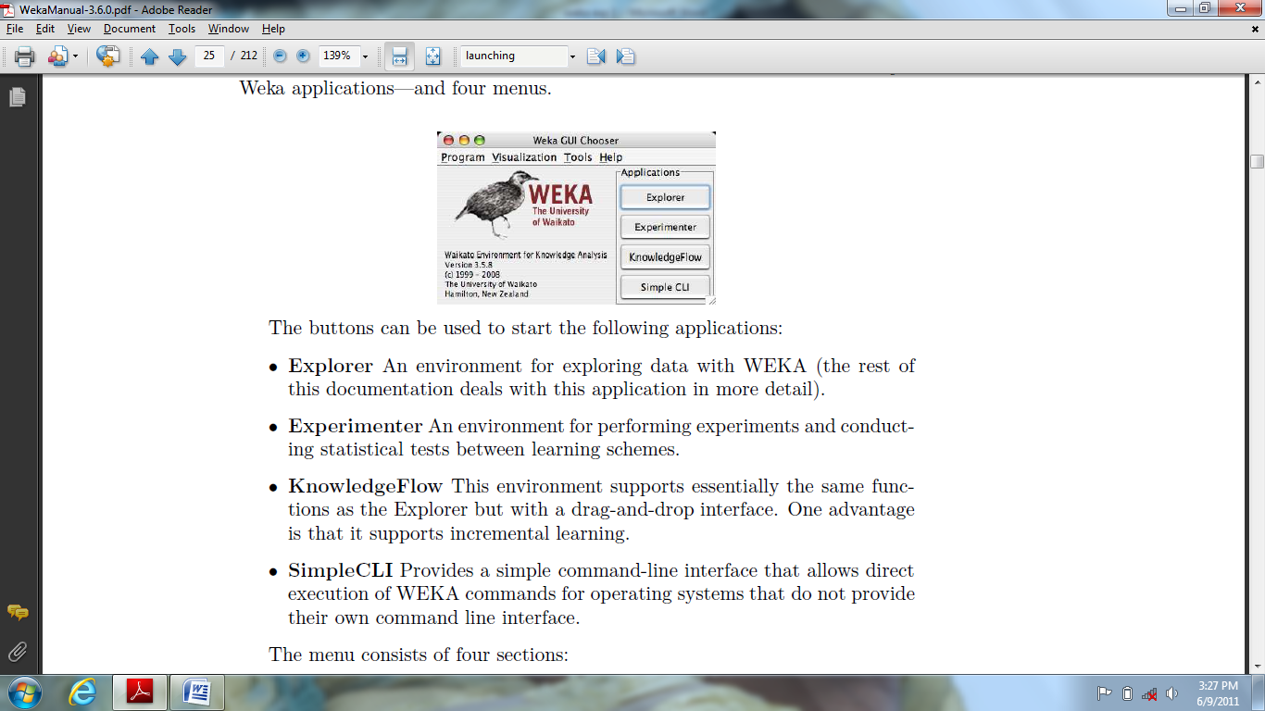

The menu consists of four sections like Program, Tools, Visualization, and Help.

**EXPLORER:**

It is a user interface which contains a group of tabs just below the title bar. The tabs are as follows:

1. Preprocess
2. Classify
3. Cluster
4. Associate
5. Select Attributes
6. Visualize

The bottom of the window contains status box, log and WEKA bird.

1. **PREPROCESSING:**

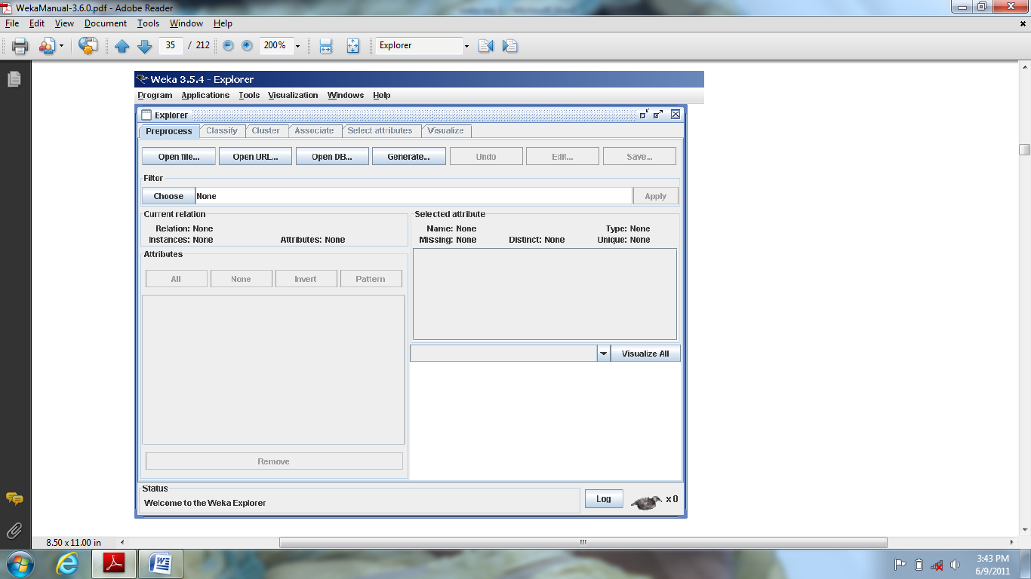

**LOADING DATA:**

The first four buttons at the top of the preprocess section enable you to load

Data into WEKA:

1. **Open file**: It shows a dialog box allowing you to browse for the data file on the local file system.
2. **Open URL**: Asks for a Uniform Resource Locator address for where the data is stored.
3. **Open DB**: Reads data from a database.
4. **Generate**: It is used to generate artificial data from a variety of Data Generators.

Using the Open file button we can read files in a variety of formats like WEKA’s ARFF format, CSV format. Typically ARFF files have .arff extension and CSV files .csv extension.

**THE CURRENT RELATION**

The Current relation box contains the currently loaded data i.e. interpreted as a single relational table in database terminology, which has three entries:

1. **Relation**: It provides the name of the relation in the file from which it was loaded. Filters are used modify the name of a relation.
2. **Instances**: The number of instances (data points/records) in the data.
3. **Attributes**: The number of attributes (features) in the data.

**ATTRIBUTES**

It is located below the current relation box which contains four buttons, they are:

1) **All** is used to tick all boxes 2) **None** is used to clear all boxes 3) **Invert** is used make ticked boxes unticked. 4) **Pattern** is used to select attributes by representing an expression. E.g. a.* is used to select all the attributes that begins with a.

**SELECTED ATTRIBUTE:**

It is located beside the current relation box which contains the following:

1. **Name:** It specifies the name of the attribute i.e. same as in the attribute list.
2. **Type**: It specifies the type of attribute, most commonly Nominal or Numeric.
3. **Missing:** It provides a numeric value of instances in the data for which an attribute is missing.
4. **Distinct**: It provides the number of different values that the data contains for an attribute.
5. **Unique**: it provides the number of instances in the data having a value for an attribute that no other instances have.

**FILTERS**

By clicking the **Choose** button at the left of the Filter box, it is possible to select one of the filters in WEKA. Once a filter has been selected, its name and options are shown in the field next to the Choose button, by clicking on this box with the left mouse button it shows a GenericObjectEditor dialog box which is used to configure the filter.

1. **CLASSIFICATION:**

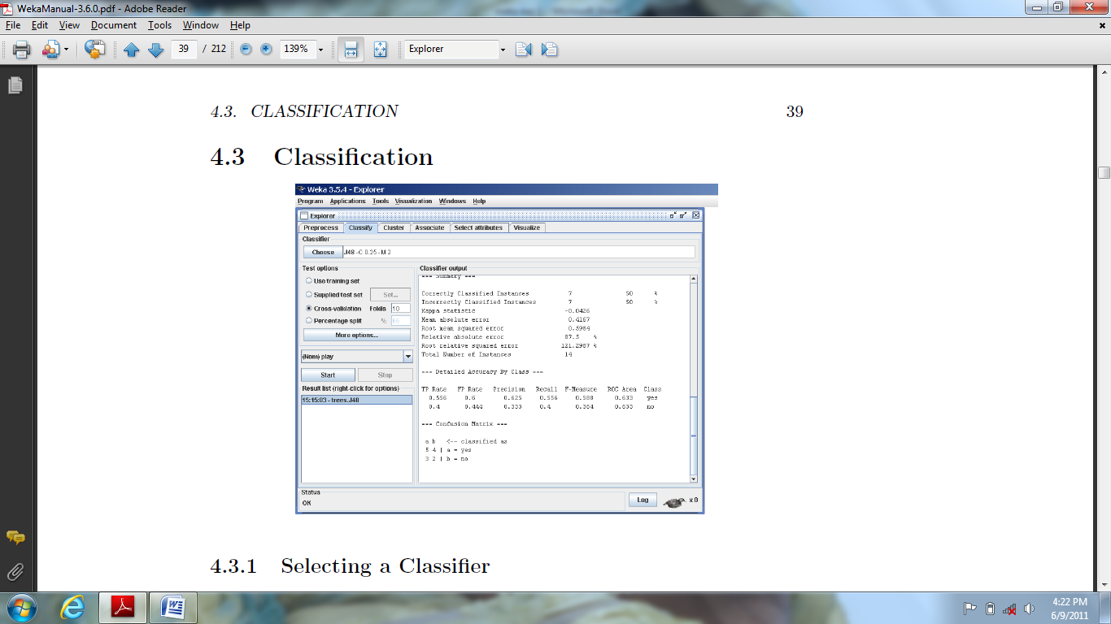

Classification has a text box which gives the name of currently selected classifier, and its options. By clicking it with the left mouse button it shows a

GenericObjectEditor dialog box, which is same as for filters i.e. used to configure the current classifier options.

**TEST OPTIONS**

The result of applying the chosen classifier will be tested according to the options that are set by clicking in the Test options box. There are four test modes:

1. Use training set.

2. Supplied test set.

3. Cross-validation.

4. Percentage split.

Once the classifier, test options and class have all been set, the learning process is started by clicking on the **Start** button. We can stop the training process at any time by clicking on the **Stop** button.

The **Classifier output** area to the right of the display is filled with text describing the results of training and testing.

After training several classifiers, the **Result List** will contain several entries using which we can move over various results that have been generated. By pressing Delete we can remove a selected entry from the results.

1. **CLUSTERING:**

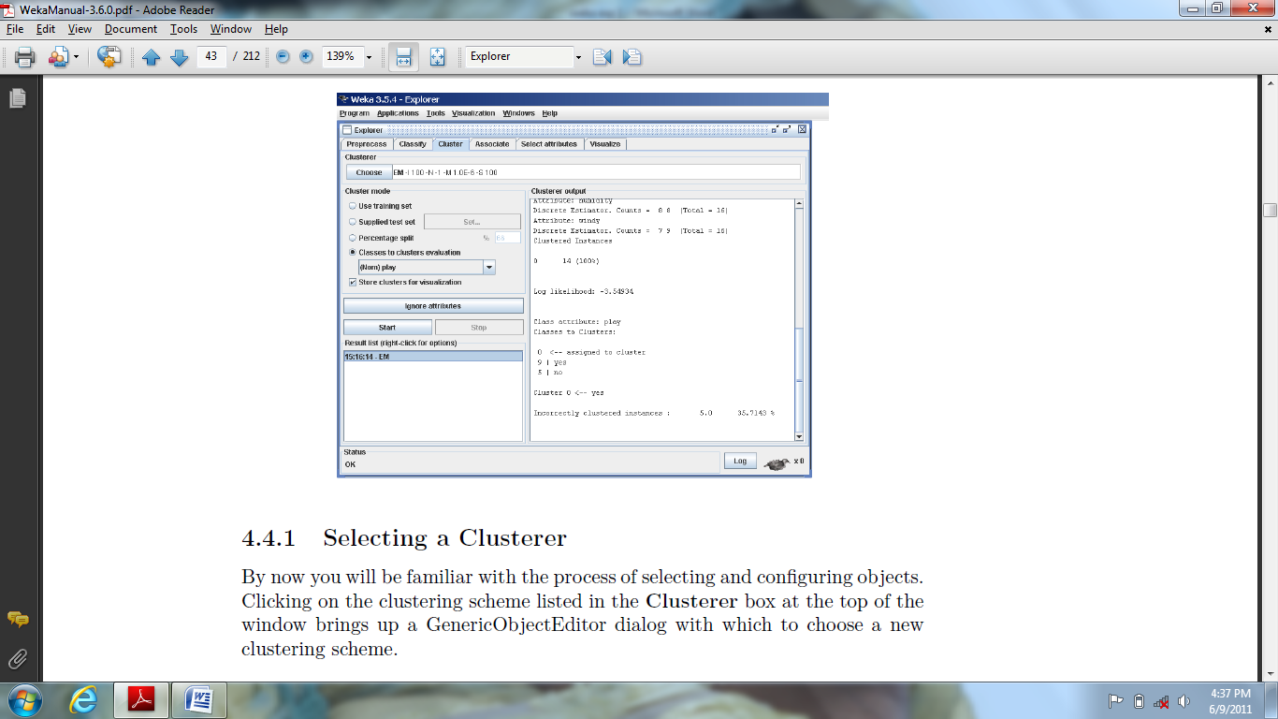

By clicking the text box beside the choose button in the **Cluster box**, it shows a dialog box used to choose a new clustering scheme.

The **Cluster mode** box is used to choose what to cluster and how to evaluate the results. The first three options in it are same as in classification like **Use training set, Supplied test set** and **Percentage split.** The fourth option is **classes to clusters evaluation.**

An additional option in the Cluster mode box is the **Store clusters for visualization** which finds whether or not it will be possible to visualize the clusters once training is complete.

**Ignore Attributes**: when clustering, some attributes in the data should be ignored. It shows a small window that allows you to select which attributes are ignored.

1. **ASSOCIATION:**

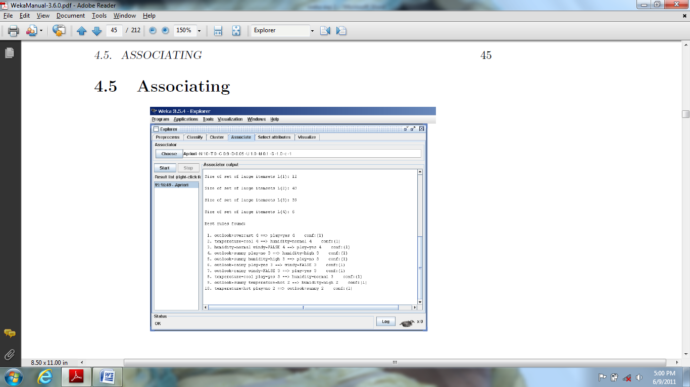

It contains schemes for learning association rules, and the learners are chosen and configured in the same way as the cluster, filters, and classifiers in the other panels.

1. **SELECTING ATTRIBUTES**

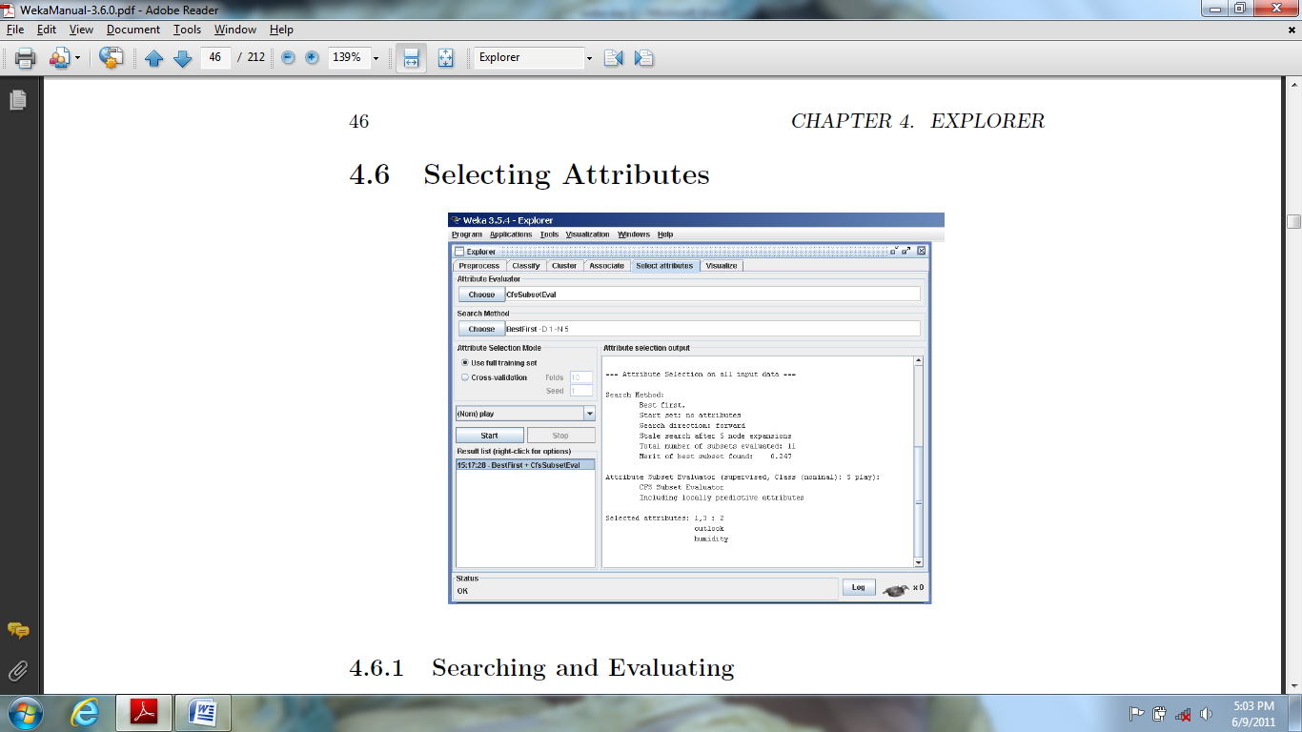

Attribute selection involves searching through all possible combinations of attributes in the data to find which subset of attributes works best for prediction. To do this, two objects must be set up: an attribute evaluator and a search method. The evaluator determines what method is used to assign a worth to each subset of attributes. The search method determines what style of search is performed.

The **Attribute Selection Mode** box has two options:

1. **Use full training set**: The worth of the attribute subset is determined using the full set of training data.

2. **Cross-validation**: The worth of the attribute subset is determined by a process of cross-validation. The Fold and Seed fields set the number of folds to use and the random seed used when shuffling the data.

1. **VISUALIZATION:**

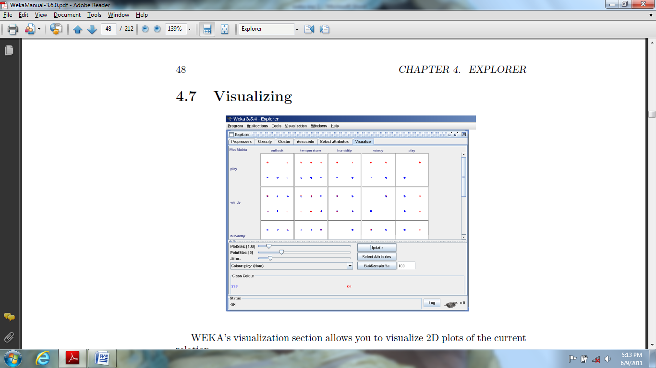

WEKA’s visualization section allows you to visualize 2D plots of the current relation.

**EXPERIMENTER:**

The Weka Experiment Environment enables the user to create, run, modify, and analyses experiments in a more convenient manner. It can also be run from the command line using the Simple CLI.

*New Experiment:*

After clicking on **new** default parameters for an Experiment are defined.

We can choose the experiment in two different modes 1) Simple and 2) Advanced

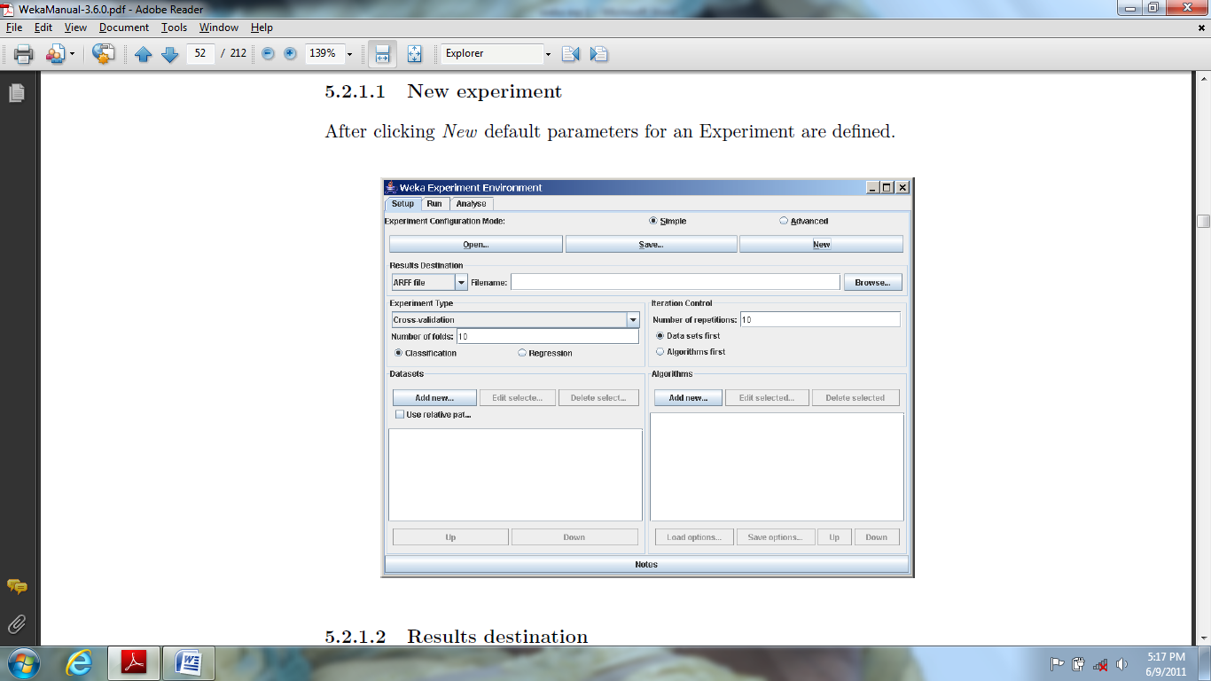

*Result Destination:*

By default, an ARFF file is the destination for the results output. But we can also choose CSV file as the destination for output file. The advantage of ARFF or CSV files is that they can be created without any additional classes. The drawback is the lack of ability to resume the interrupted experiment.

*Experiment type:*

The user can choose between the following three different types:

1. Cross-validation: it is a default type and it performs stratified cross-validation with the given number of folds.
2. Train/Test Percentage Split: it splits a dataset according to the given percentage into a train and a test file after the order of the data has been randomized and stratified.
3. Train/Test Percentage Split: As it is impossible to specify an explicit train/test files pair, one can abuse this type to un-merge previously merged train and test file into the two original files.

Additionally, one can choose between Classification and Regression, depending on the datasets and classifiers one uses.

*Data Sets:*

One can add dataset files either with an absolute path or with a relative path.

*Iteration control:*

1. *Number of repetitions*: In order to get statistically meaningful results, the default number of iterations is 10.
2. *Data sets first/Algorithms first*: As soon as one has more than one dataset and algorithm, it can be useful to switch from datasets being iterated over first to algorithms.

Algorithms: New algorithms can be added via the “Add New” button.

Opening this dialog for the first time, ZeroR is presented.



By clicking on the Choose button one can choose another classifier which is as shown in the below diagram:



The “Filter...” button enables us to highlight classifiers that can handle certain attributes and class types. With “Remove Filter” button one can clear the classifiers that are highlighted earlier.

With the Load options... and Save options... buttons one can load and save the setup of a selected classifier from and to XML.

*Running an Experiment:*

To run the current experiment, click the Run tab at the top of the Experiment Environment window. The current experiment performs 10 runs of 10-fold stratified cross-validation.



After clicking the Run tab, it shows a window with start button and stop button, by clicking on start button we can run the experiment and by clicking on stop button we can run the experiment.



If the experiment was defined correctly, the 3 messages shown above will be displayed in the Log panel.

**Advanced**

Defining an experiment: When the Experimenter is started in Advanced mode, the Setup tab is displayed. Now click New to initialize an experiment.



To define the dataset to be processed by a scheme, first select Use relative paths in the Datasets panel of the Setup tab and then click on Add new... button.

Saving Results of the experiment

To identify a dataset to which the results are to be sent, click on the Instances- ResultListener entry in the Destination panel, which opens a dialog box with a label named as “output file”.



Now give the name of the output file and click on OK button. The dataset name is now displayed in the Datasets panel of the Setup tab. This is as shown in the following figure:



Now we can run the experiment by clicking the Run tab at the top of the experiment environment window. The current experiment performs 10 randomized train and test runs.

To change from random train and test experiments to cross-validation experiments, click on the *Result generator* entry.

Using analysis tab in experiment environment window one can analyze the results of experiments using experiment analyzer.

**KNOWLEDGE FLOW:**

The Knowledge Flow provides an alternative to the Explorer as a graphical front end to WEKA’s core algorithms. It is represented as shown in the following figure. The Knowledge Flow presents a data-flow inspired interface to WEKA.

The Knowledge Flow offers the following features:

1. Intuitive data flow style layout.
2. Process data in batches or incrementally.
3. Process multiple batches or streams in parallel (each separate flow executes in its own thread).
4. Chain filters together.
5. View models produced by classifiers for each fold in a cross validation.
6. visualize performance of incremental classifiers during processing
7. Plug-in facility for allowing easy addition of new components to the Knowledge Flow.



**Components:**



1. Data Sources: All WEKA loaders are available.
2. Data Sinks: All WEKA savers are available.
3. Filters: All WEKA’s filters are available.
4. Classifiers: All WEKA classifiers are available.
5. Cluster: All WEKA cluster are available.
6. Evaluation: It contains different kinds of techniques like TrainingSetMaker, TestSetMaker, CrossValidationFoldMaker, TrainTestSplitMaker, ClassAssigner, ClassValuePicker, ClassifierPerformanceEvaluator, IncrementalClassifierEvaluator, ClustererPerformanceEvaluator, and PredictionAppender.
7. Visualization: It contains different models like DataVisualizer, ScatterPlotMatrix, AttributeSummarizer, ModelPerformanceChart, TextViewer, GraphViewerbased, and StripChart.

**Plug-in Facility:**

The Knowledge Flow offers the ability to easily add new components via a plug-in mechanism.

**SIMPLE CLI:**

The Simple CLI provides full access to all Weka classes like classifiers, filters, clusters, etc., but without the hassle of the CLASSPATH.

It offers a simple Weka shell with separated command line and output.

The simple command line interface is represented as shown in the following figure:



The following commands are available in the Simple CLI:

1. *java <classname> [<args>]: -* invokes a java class with the given arguments (if any)
2. *break: -* it stops the current thread in a friendly manner. e.g., a running classifier
3. *kill: -* stops the current thread in an unfriendly fashion
4. *cls:-* clears the output area
5. ***exit:-*** exits the Simple CLI
6. ***help [<command>]:-*** provides an information about the command available in the simple CLI. Also it provides an overview of all commands available if the command is not specified as an argument.

In order to invoke a Weka class, only the way is one has to prefix the class with”java”. This command tells the Simple CLI to load a class and execute it with any given parameters.

For example: **java weka.classifiers.trees.J48 -t c:/temp/iris.arff** which results in the following output.



Using simple CLI we can also perform command redirection using the operator “>”. For example: **java weka.classifiers.trees.J48 -t test.arff > j48.txt**

**2: TO CREATE DATA IN .CSV FORMAT**

**Aim:** To create data in.CSV format

**Input:** bank data

**Procedure:**

1. Open MS Excel. Create a new worksheet with respective field headings and data.
2. Save the file with .CSV extension.(bankdata.CSV)
3. Open weka preprocess tab in the explorer.
4. Click open file button and browse the file and open it.

Load the desired .CSV file using **open file…** as shown..,

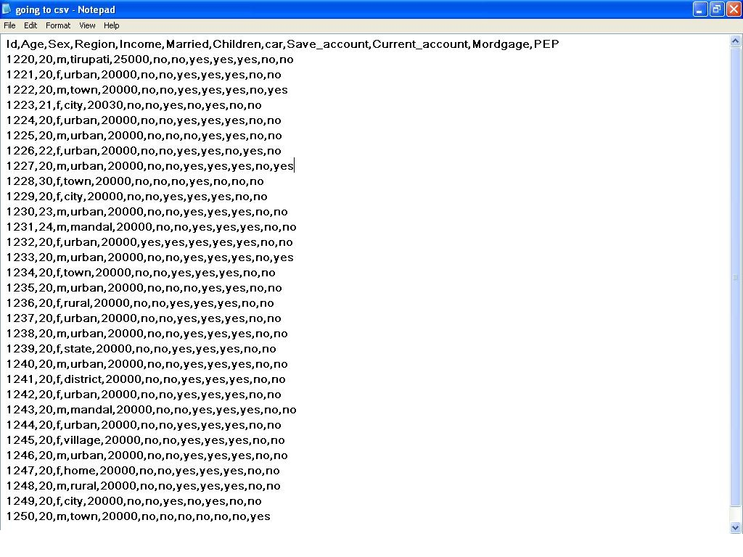

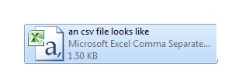

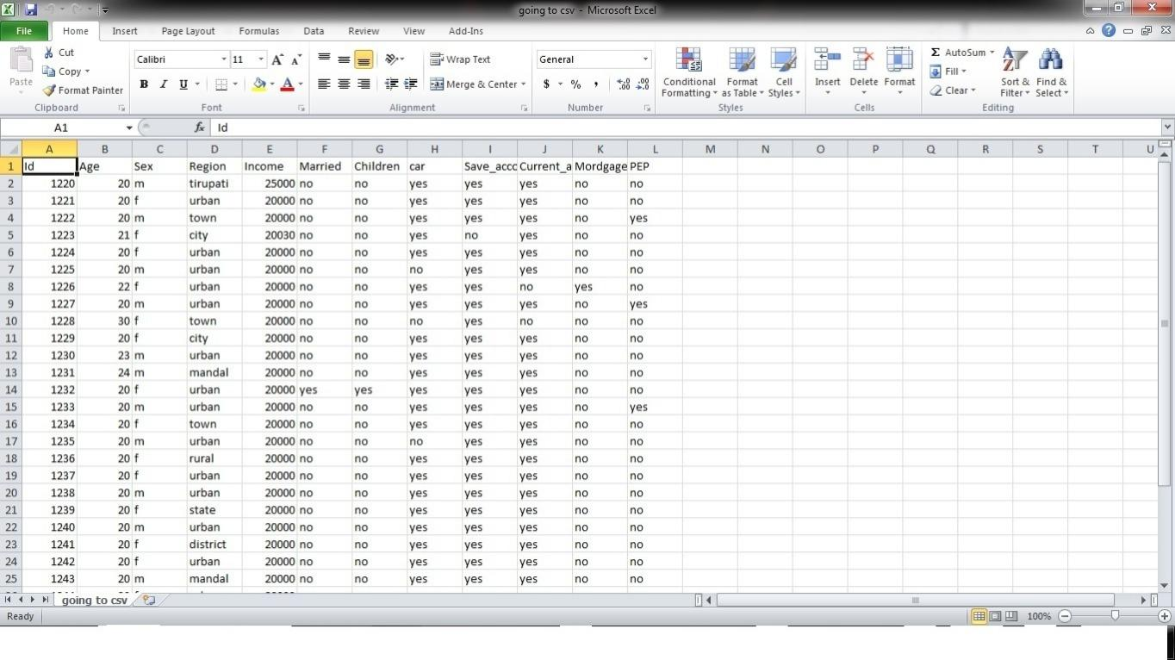

**Output:** Bankdata.csv is successfully created.

**3: Create data in .ARFF format**

**Aim:** To create data in .arff format.

**Input:** bankdata.arff

**Procedure:**

1. Open notepad and type the arff header information.
2. Add data with respective to the given headers.
3. Save file as bankdata with .arff extension.
4. Open Preprocess tab of Weka in the explorer.
5. Click Open file tab and browse for the bankdata.arff.
6. If the data has been entered without any errors, then the file details will be available on the Preprocessor screen.

Insert data fields in note pad like shown and save with extension **.arff** choosing **all files** in file of type :

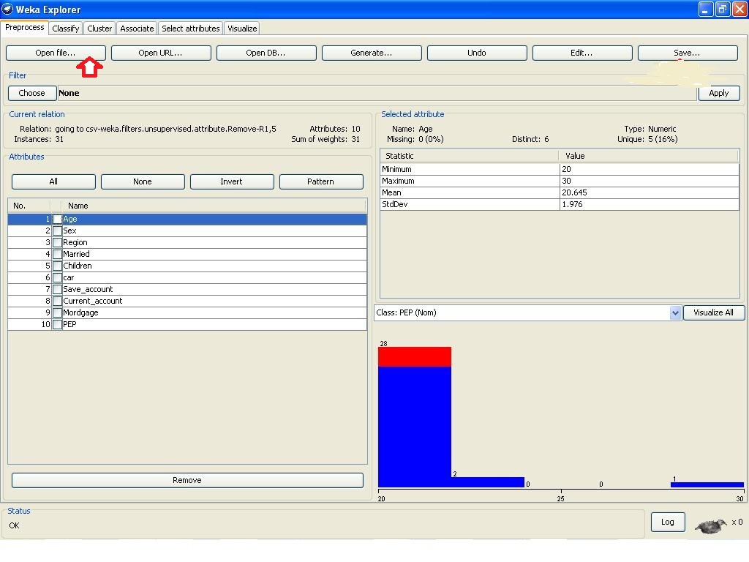

Click **save**  as shown….,diag box opens save with extension as **.arff**

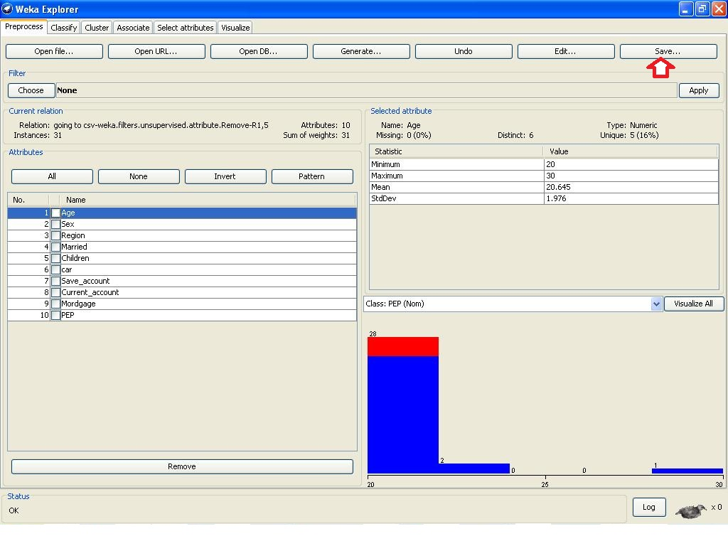

AN ARFF FILE LOOKS LIKE 

**Output:**

If the dataset has been stored properly, then bankdata.arff would have been created successfully and all the attributes and its values will be available to the user for mining purposes.

**4: PREPROCESSING**

**Aim:**  Preprocessing in Weka

It is a process of identifying the unwanted data (data cleaning) before loading the data from the data base.

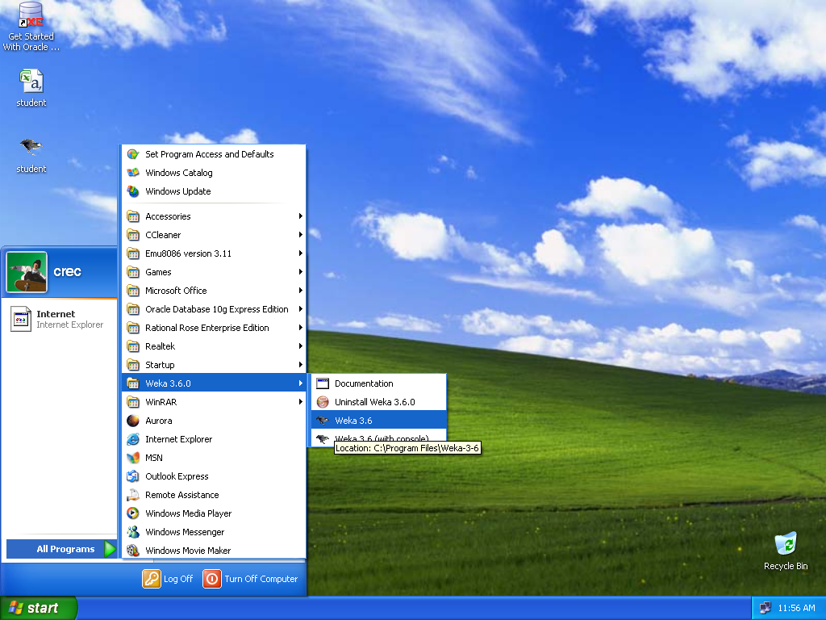

Fig- 1

1. Open the Weka application as shown in the above fig- 1.

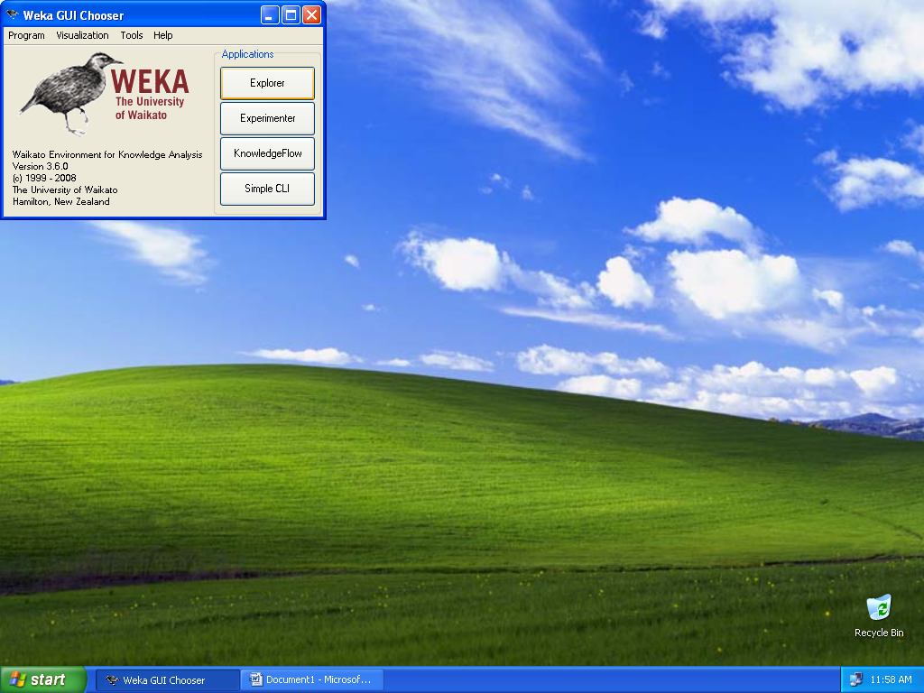

Fig- 2

1. Now Click on Explorer as shown in the above fig- 2.

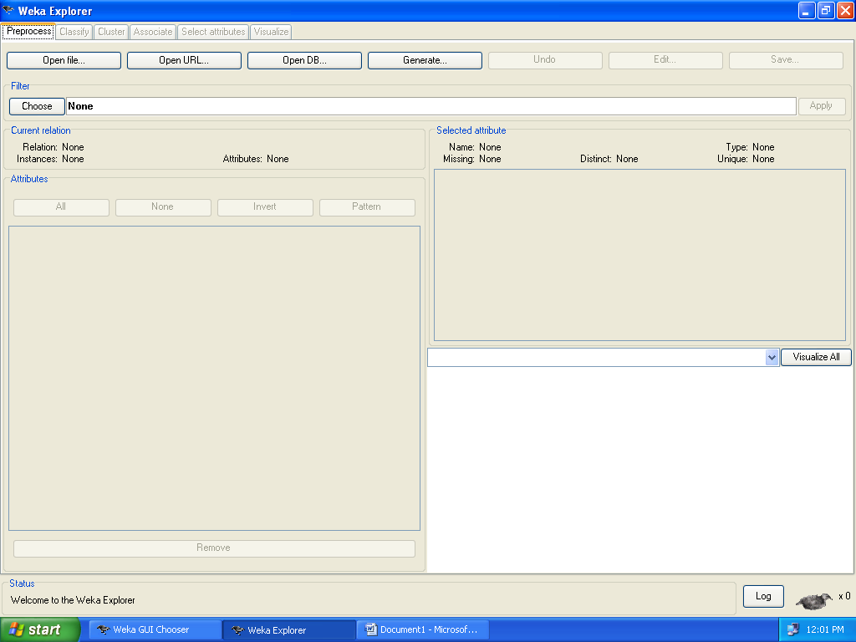

Fig- 3

1. Now open file by choosing the “open file” button as shown in the above fig- 3.

Relation specifies the name of the database used, instances specify the objects involved, and attributes specify the number of attributes used in the data base or relation.

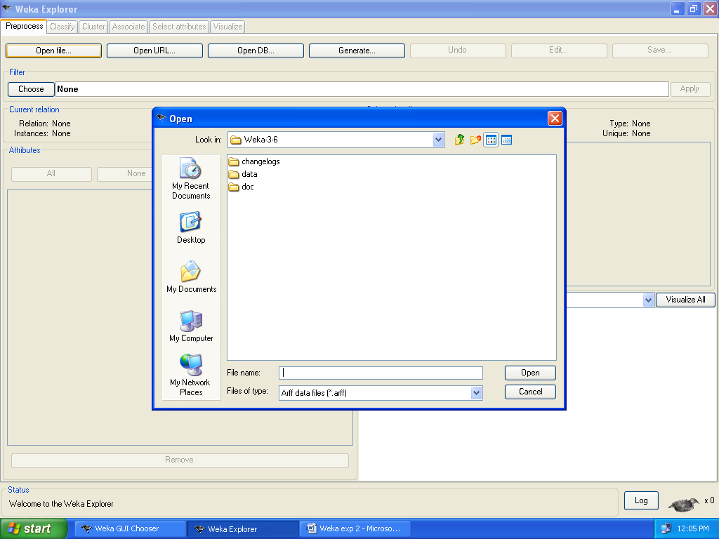

Fig- 4

1. Now choose the data folder in the open dialogue box as in fig- 4.

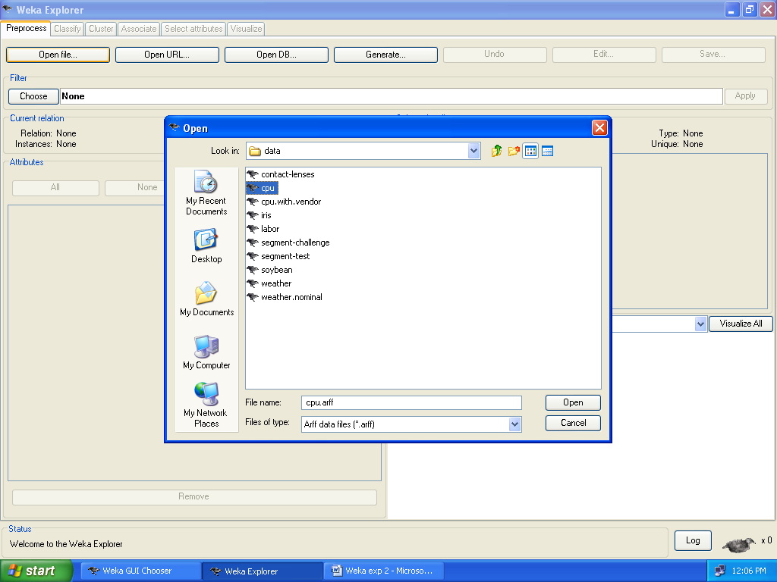

Fig- 5

1. Now choose the “cpu.arff” file in the above fig- 5.

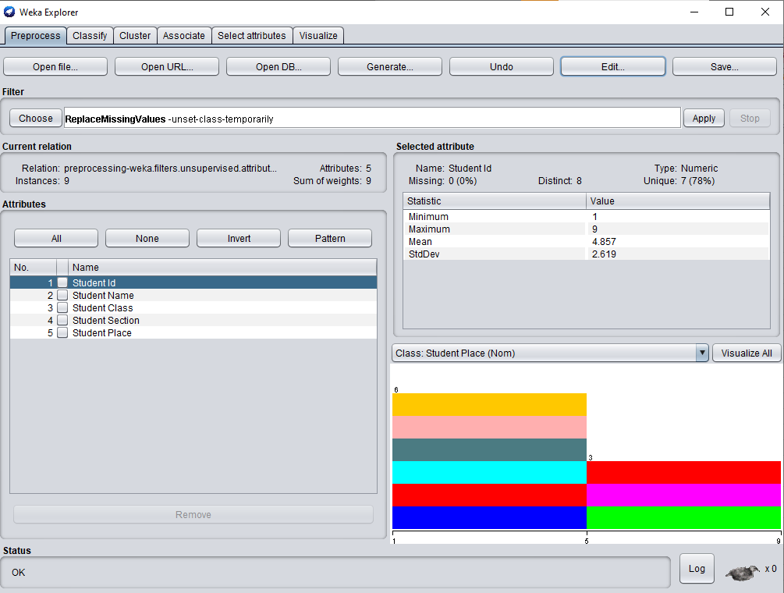

Fig- 6

1. Select any attribute in the attributes section (for e.g. class as shown in Fig- 6) and click on remove button as shown in the fig- 7 below.

On right Side of the window we have the selected attribute field which specifies the following options like:

**Name:** It specifies the name of the attribute.

**Missing:** It specifies the missing values in the attribute.

**Type:** It specifies the type of attribute used in the database like nominal or numeric or string etc…

**Unique:** It specifies unique attributes available in the relation

**How to handle missing values:**

* Missing Values in Numerical Columns
  + Replace it with a constant value. This can be a good approach when used in discussion with the domain expert for the data we are dealing with.
  + Replace it with the mean or median. This is a decent approach when the data size is small—but it does add bias.
  + Replace it with values by using information from other columns.
* Predicting Missing Values Using an Algorithm
* Missing Values in Categorical Columns

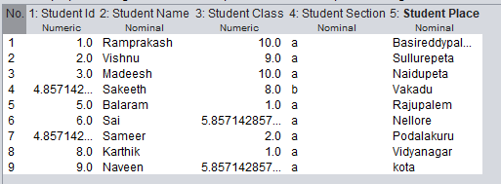

Fig-7

1. Finally the result is obtained as shown in the fig- 7.

**Output:** Results are displayed in the Test Output Window.

**5: DATA REDUCTION STRATEGY – DIMENSIONALITY REDUCTION OR ATTRIBUTE REMOVAL**

**Aim:** To remove an attribute and its values from a dataset.

**Input:** iris.arff

**Procedure:**

We can directly remove the attribute: by selecting the attribute and click **REMOVE**  as shown in fig

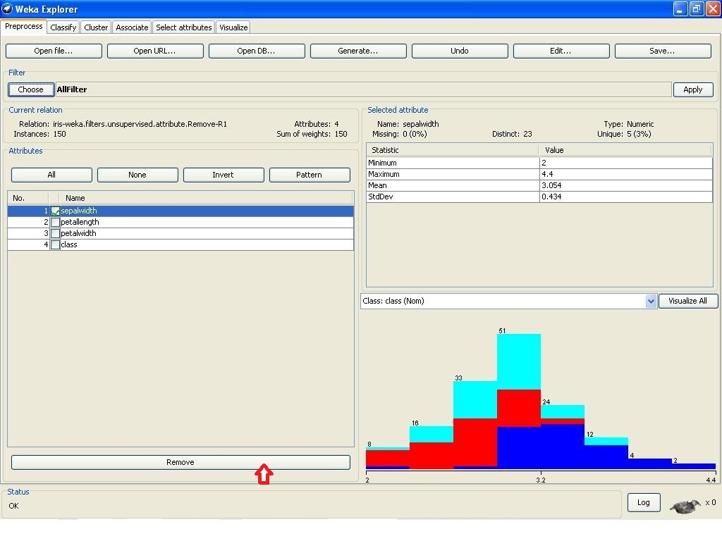

OR we can choose fiter **REMOVE**  as shown

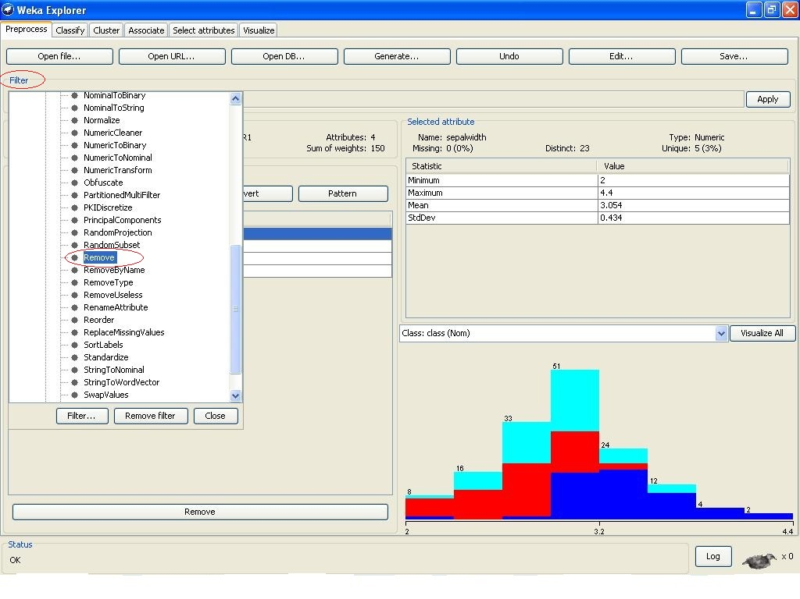

Even we can specify the attribute indices by: **right clicking over the filter box** , this opens dialog box as..,

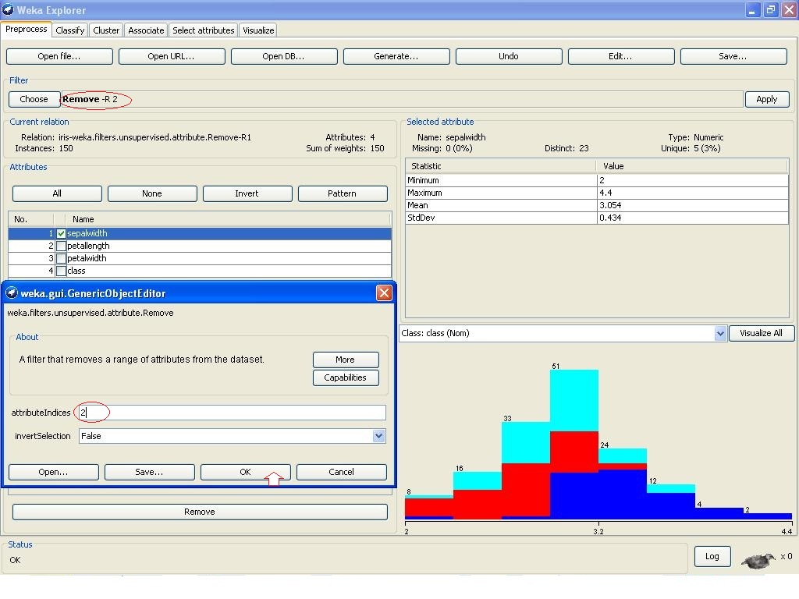

Finally the attribute list after mining with **Remove** filter.,

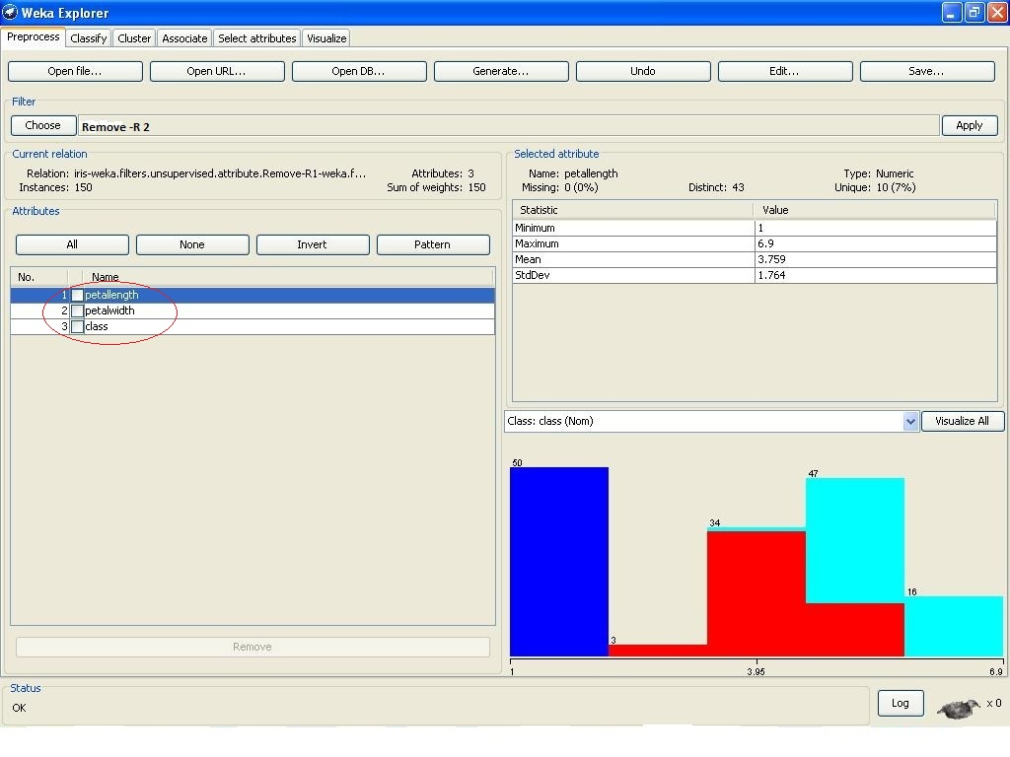

Click on save button and store the modified dataset with a new name as irismod.arff.

**Output:** Irismod.arff has a new list of attributes after been removed of an attribute.

**6: DATA NORMALIZATION**

**Aim:** To normalize the data in a given dataset.

**Components Used:**

|  |  |  |
| --- | --- | --- |
| Name of the icon | Tab | Purpose |
| ArffLoader | DataSources | To choose a dataset of arff |
| AttributeSelection | Filters | To select attributes using EvaluatorSearch method |
| Normalize | Filters | To make the numerical dataset values exist between boundaries of 0 and 1 |
| Csvsaver | DataSinks | To make output appear in a separate csv file format |

**Procedure:**

**Linking and arranging the icons for ‘normalize’**

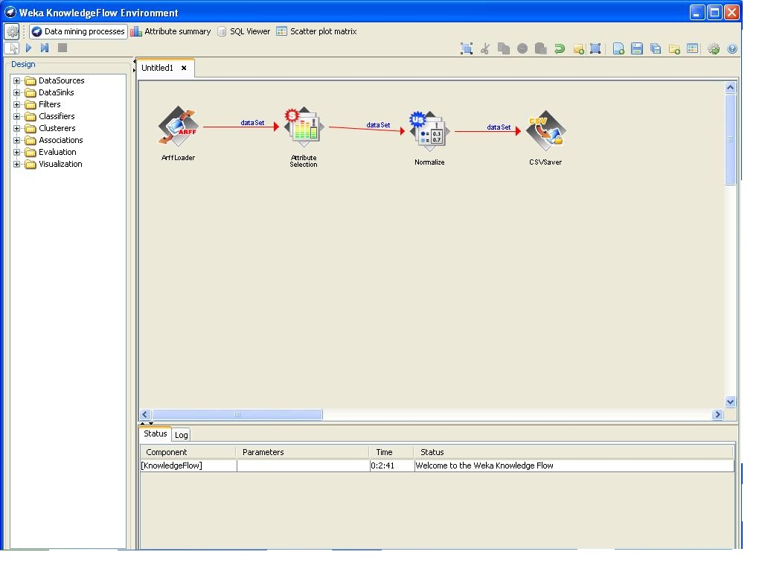

Load the file by right click over the **Arff loader** in configure…tab**;** and right over the **csv saver** and load as shown

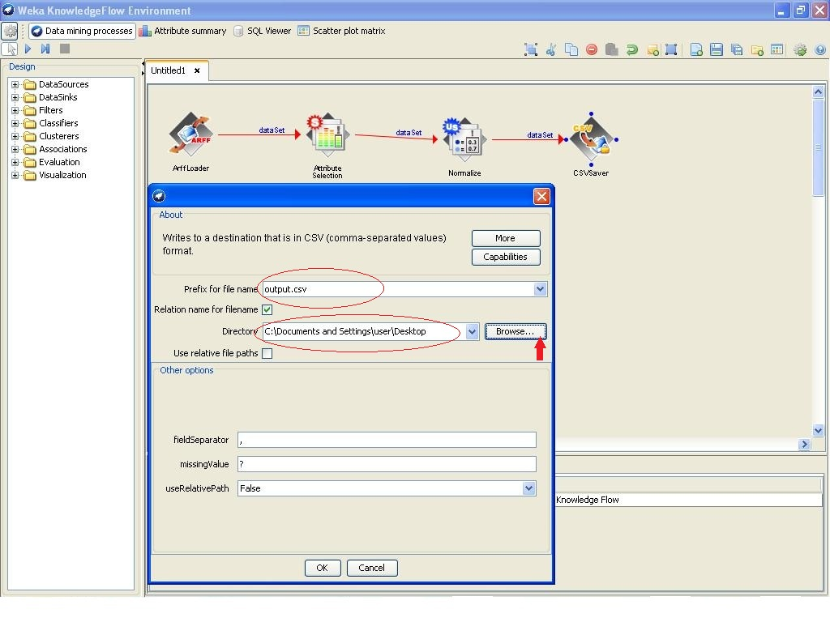

In the above we given the destination as desktop; the resultant **csv file** stores in desktop looks like..,



So result can be viewed as double over the resultant csv file that open’s in **MS-EXCEL WORK SHEET**

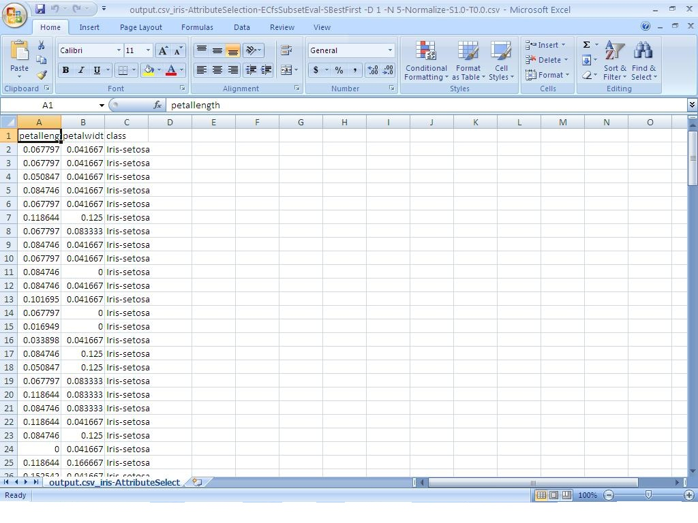

**Output:** output.csv has the stored results.

**7: CLASSIFICATION**

**Aim:** Classification in Weka Using Decision Trees

**Procedure**: It is necessary to provide a clear classification of data mining systems which may help users to distinguish between such systems and to identify them.

Data mining classification can be done in different ways:

1. Data mining can be classified according to the kinds of databases mined
2. Data mining can be Classified according to the kinds of knowledge mined which is done based on the mining functionalities like characterization, discrimination etc…
3. We can also classify the data mining systems according to the kinds of techniques utilized, applications adapted.

**Decision Tree Algorithm:** Classification of data can be done by using decision tree algorithms like J48.

**J48 Algorithm**:

It is a version of an earlier algorithm named as C4.5 **decision tree algorithm** which is a classic way to represent information from machine learning algorithm.

J48 algorithm gives several options related to tree pruning. The basic idea of the algorithm is to recursively classify the data until each leaf is pure.

J48 uses mainly two pruning methods namely

1. Sub-tree replacement: Where the nodes in a decision tree are replaced with a leaf. This process starts from leaf towards the root.
2. Sub-tree raising: Where nodes may be moved upwards towards the root of the tree, replacing the other nodes along the way.

Now Open the WEKA GUI Chooser from start menu🡪all programs and click on the EXPLORER button.

Click on the **Open File** button and choose the file named as “classify.csv” where the content of classify.csv is as shown in the fig- 1.

|  |  |  |  |  |  |
| --- | --- | --- | --- | --- | --- |
| **Customer ID** | **Age** | **Income** | **Student** | **Credit Rating** | **Class by Computer** |
| 1 | Youth | High | No | Fair | No |
| 2 | Youth | High | No | Excellent | No |
| 3 | Middle | High | No | Fair | Yes |
| 4 | Senior | Medium | No | Fair | Yes |
| 5 | Senior | Low | Yes | Fair | Yes |
| 6 | Senior | Low | Yes | Excellent | No |
| 7 | Middle | Low | Yes | Excellent | Yes |
| 8 | Youth | Medium | No | Fair | No |
| 9 | Youth | Low | Yes | Fair | Yes |
| 10 | Senior | Medium | Yes | Fair | Yes |
| 11 | Youth | Medium | Yes | Excellent | Yes |
| 12 | Middle | Medium | No | Excellent | Yes |
| 13 | Middle | High | Yes | Fair | Yes |
| 14 | Senior | Medium | No | Excellent | No |

Fig- 1: Input File (CLASSIFY.CSV)

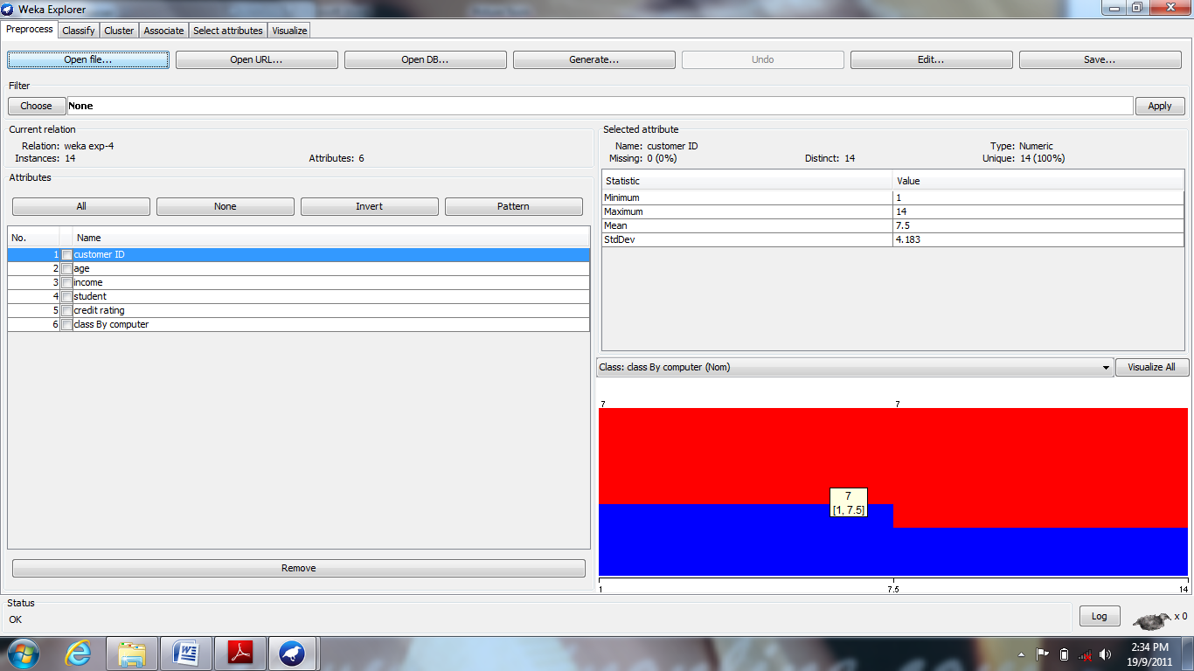

FIG- 2: Load The File CLASSIFY.CSV

After loading the input file named classify.csv as shown in fig- 2, choose the classify tab in the Weka explorer window. Under the classify tab click on choose button and select the J48 under tree as shown in the following fig- 3.

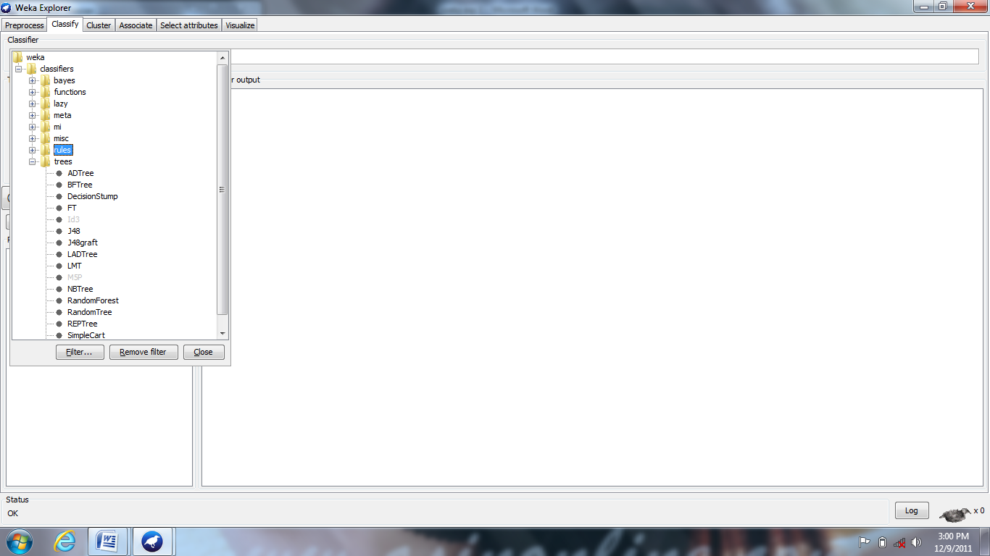

Fig- 3: Selecting J48 Algorithm (Decision Tree Algorithm)

Now select the “**use training set** “under the **Test Options** located at the left of the WEKA explorer window and click on **start** button.

The output is represented in the **Classifier Output** window in weka explorer window, which is as shown in fig- 4 below:

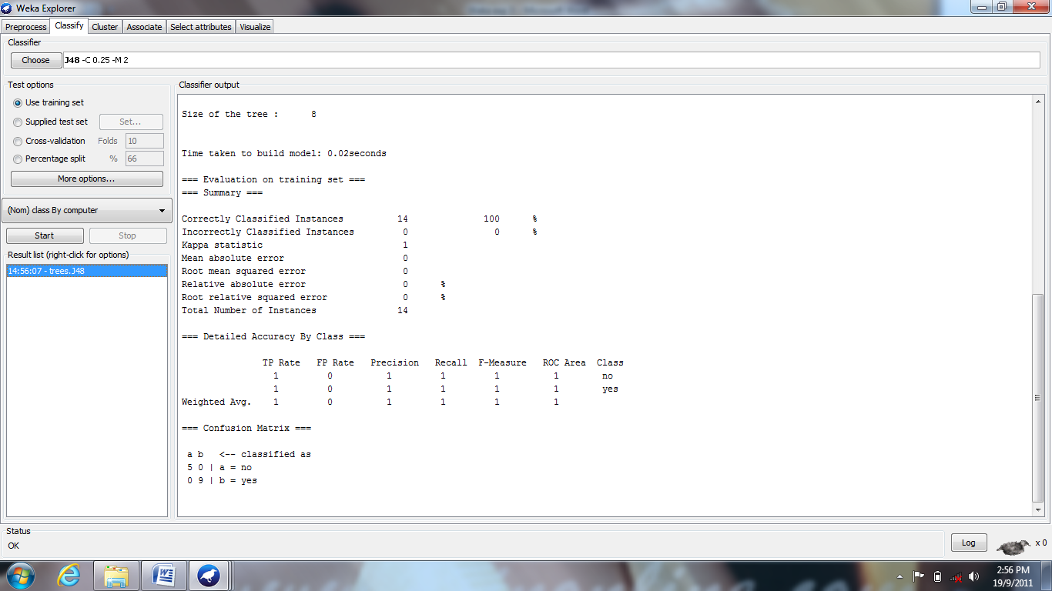

Fig- 4: Showing Output In Classifier Output Window In Weka Explorer Window

We can also view the output in a separate window by right clicking on the option in **Result list** and clicking on “**view in separate window”** as shown in fig- 5**.**

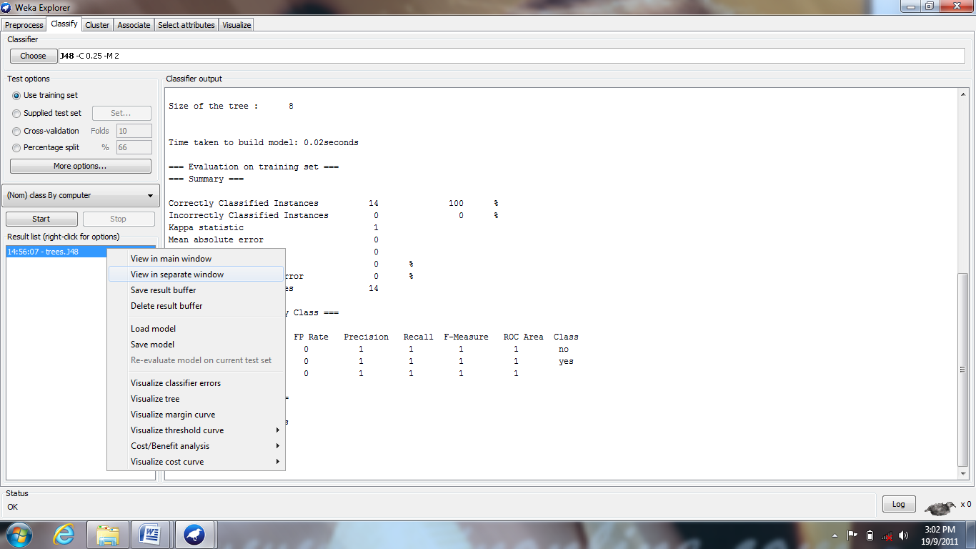

Fig- 5: Selecting The Option "View Separate Window"

The output is viewed in a separate window as shown in fig- 6 below:

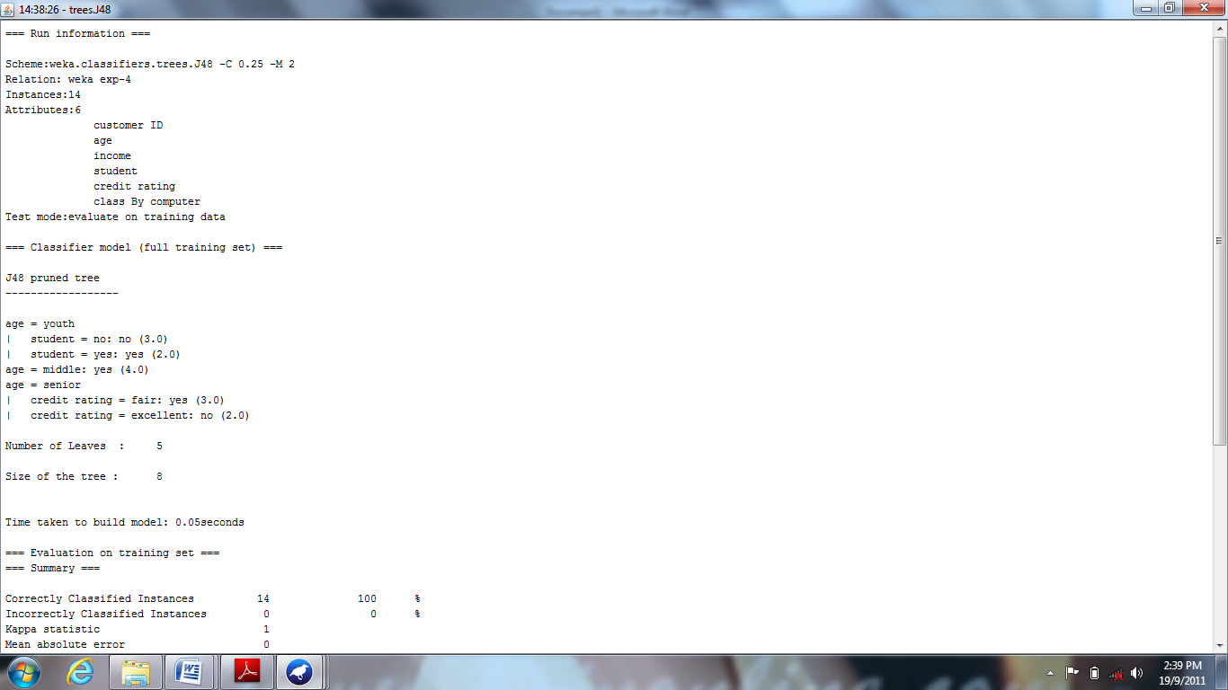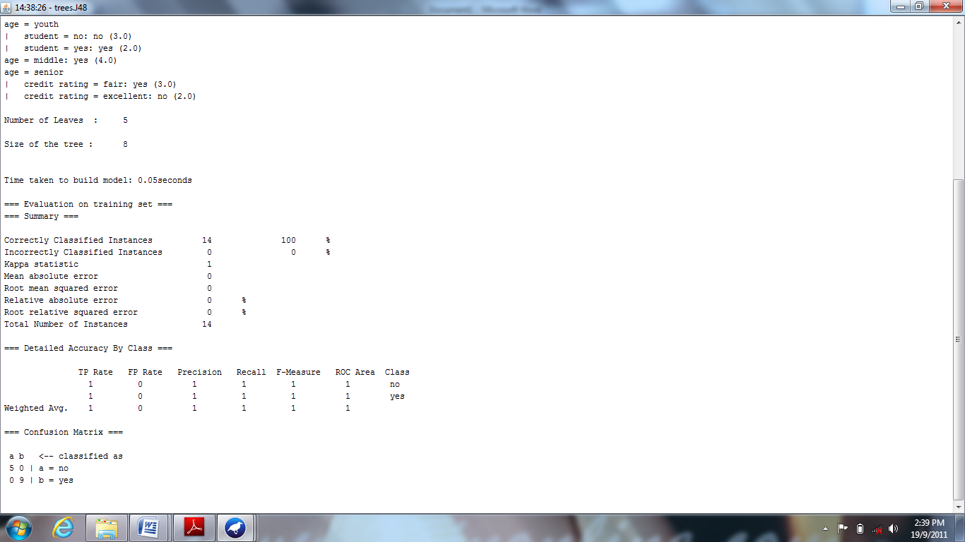

Fig- 6: Output Screen In A Separate Window

Under the **Result List** right click the item to get the options as shown in the fig- 7 and select the option “**visualize tree**” option.

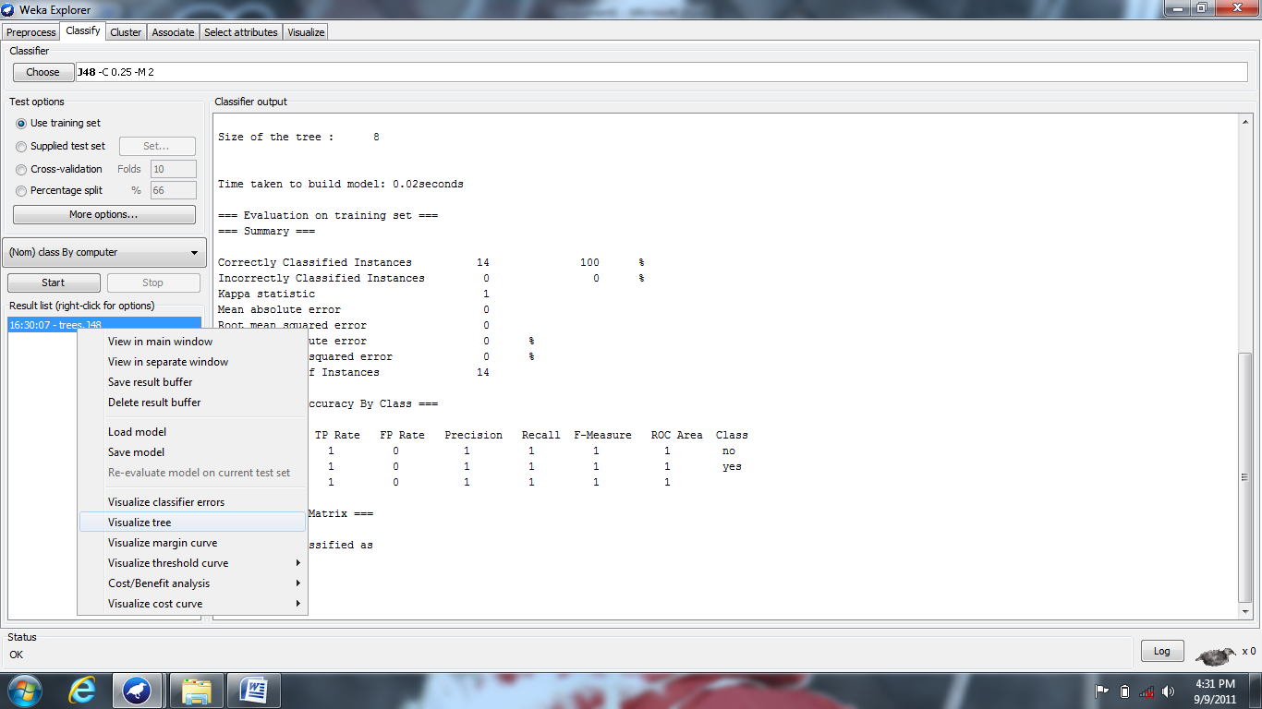

Fig- 7: Output Screen Shows How to Select Visualize As Tree Option

After selecting the” **visualize tree**” option the output is represented as a tree in a separate window as shown in the fig- 8 given below.

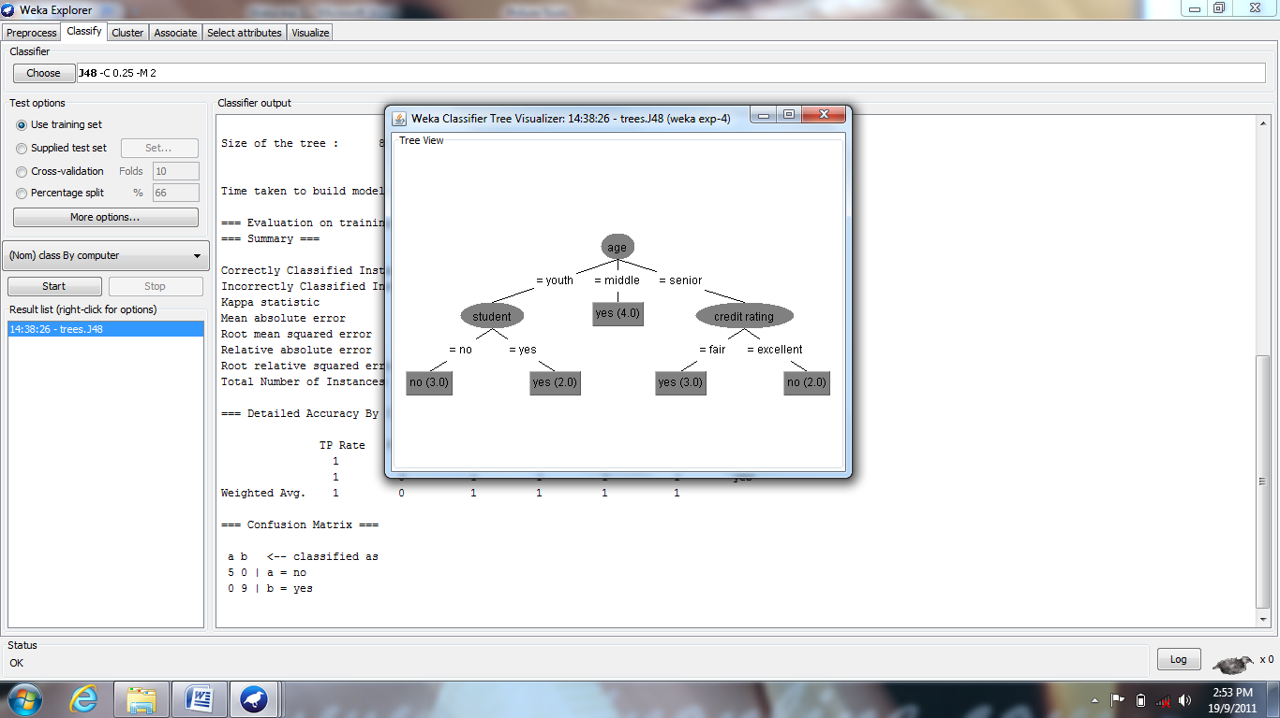

Fig- 8: Tree Output of Classification

**Output:** Results are displayed in the Test Output Window.

**8: DECISION TREE INDUCTION USING J48 CLASSIFIER**

**Aim:**

To perform decision tree induction on .arff file by using nominal attributes for classification using J48 classifier.

**Input:** weather.arff

**Procedure:**

1. In preprocess tab, choose the input file.
2. Classify tab has an option to select the J48 algorithm.
3. Click on the url tab’s choose option where GUI generic object editor dialog opens.
4. Save instance data and choose the number of folds.

Click === Run information ===

Scheme: weka.classifiers.trees.J48 -C 0.25 -M 2

Relation: weather

Instances: 14

Attributes: 5

outlook

temperature

humidity

windy

play

Test mode: 10-fold cross-validation

=== Classifier model (full training set) ===

J48 pruned tree

play = yes

| humidity<= 70: sunny (3.0/1.0)

| humidity> 70

| | temperature <= 71: rainy (2.0)

| | temperature > 71: overcast (4.0/1.0)

play = no

| temperature<= 71: rainy (2.0)

| temperature> 71: sunny (3.0)

Number of Leaves : 5

Size of the tree : 9

Time taken to build model: 0 seconds

=== Stratified cross-validation ===

=== Summary ===

Correctly Classified Instances 5 35.7143 %

Incorrectly Classified Instances 9 64.2857 %

Kappa statistic 0.0233

Mean absolute error 0.4246

Root mean squared error 0.6137

Relative absolute error 91.6881 %

Root relative squared error 124.5154 %

Coverage of cases (0.95 level) 57.1429 %

Mean rel. region size (0.95 level) 45.2381 %

Total Number of Instances 14

=== Detailed Accuracy By Class ===

TP Rate FP Rate Precision Recall F-Measure ROC Area Class

0.4 0.333 0.4 0.4 0.4 0.578 sunny

0.25 0.2 0.333 0.25 0.286 0.55 overcast

0.4 0.444 0.333 0.4 0.364 0.5 rainy

Weighted Avg. 0.357 0.335 0.357 0.357 0.354 0.542

=== Confusion Matrix ===

a b c <-- classified as

2 1 2 | a = sunny

1 1 2 | b = overcast

2 1 2 | c = rainy

J48 PRUNED TREE

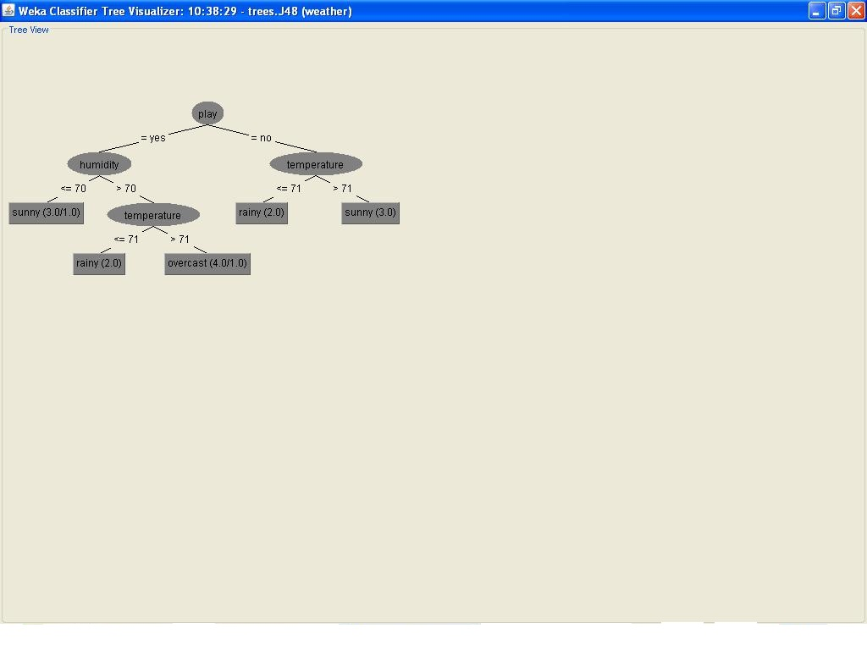

**Output:** Decision tree is generated.

**9 : CLASSIFICATION USING MULTILAYER PERCEPTRON**

**Aim:** Classification using Multilayer Perceptron

There is a necessity to provide a clear classification of data mining systems which may help users to distinguish between such systems and to identify them.

Data mining classification can be done in different ways:

* Data mining can be classified according to the kinds of databases mined.
* Data mining can be classified according to the kinds of knowledge mined which is done based on the mining functionalities like characterization, discrimination etc.
* We can also classify the data mining systems according to the kinds of techniques utilized, applications adapted.

**Neural Network Model:**

This model usually called as Neural Network which is a mathematical or a computational model.

**Multilayer Perceptron:**

Multilayer Perceptron is a feed forward artificial neural network model that maps set of input data on to a set of appropriate output which consists of multiple layers of nodes in a directed graph with each layer fully connected to next one except for the input nodes, each node is a neuron also called as processing element with a nonlinear activation function. It is a modification of the standard linear perceptron which can distinguish data i.e. not linearly separable.

**Procedure:**

Open the Weka GUI Chooser from start menu to all programs and to Weka 3.6.5 and click on Weka 3.6 and click the Explorer button on it.

Now open a file by clicking on the Open File button and choose the file named as “CAMLP.CSV” where the content of caviamlp.csv is as shown in the fig- 1.

|  |  |  |  |  |  |
| --- | --- | --- | --- | --- | --- |
| **Customer ID** | **Age** | **Income** | **Student** | **Credit Rating** | **Class by Computer** |
| 1 | Youth | High | No | Fair | No |
| 2 | Youth | High | No | Excellent | No |
| 3 | Middle | High | No | Fair | Yes |
| 4 | Senior | Medium | No | Fair | Yes |
| 5 | Senior | Low | Yes | Fair | Yes |
| 6 | Senior | Low | Yes | Excellent | No |
| 7 | Middle | Low | Yes | Excellent | Yes |
| 8 | Youth | Medium | No | Fair | No |
| 9 | Youth | Low | Yes | Fair | Yes |
| 10 | Senior | Medium | Yes | Fair | Yes |
| 11 | Youth | Medium | Yes | Excellent | Yes |
| 12 | Middle | Medium | No | Excellent | Yes |
| 13 | Middle | High | Yes | Fair | Yes |
| 14 | Senior | Medium | No | Excellent | No |

Fig- 1: Input File (CAMLP.CSV)

Loading the input file into the explorer to perform the classification as shown in the below fig- 2.



Fig- 2: Load The File CAMLP.CSV

After loading the input file named camlp.csv as shown in fig- 2, choose the classify tab in the Weka explorer window. Under the classify tab click on choose button and select the Multilayer Perceptron under functions as shown in the following fig- 3.

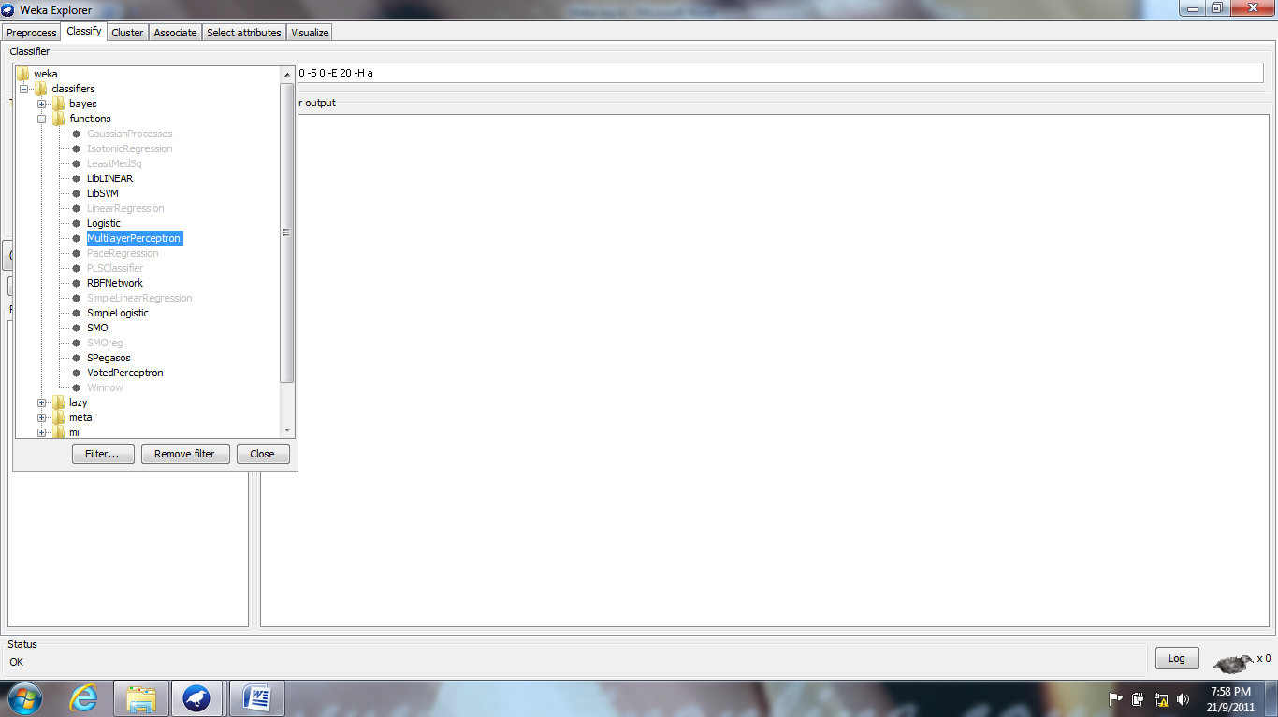

**Fig-3: Selecting the Multilayer Perceptron**

Select the “use training set” under the Test Options located at the left of the weka explorer window and click on start button. The output is represented in the Classifier Output window in weka explorer window, which is as shown in fig- 4 below:

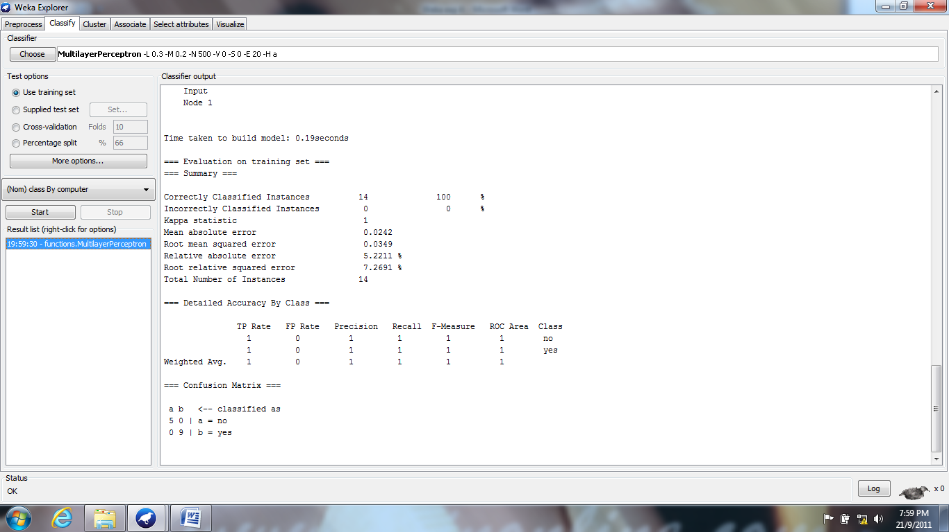

Fig- 4: Showing Output In Classifier Output Window In Weka Explorer Window

Now we are able to view the output in a separate window by right clicking on the option in result list and clicking on “view in separate window” as shown in fig- 5.

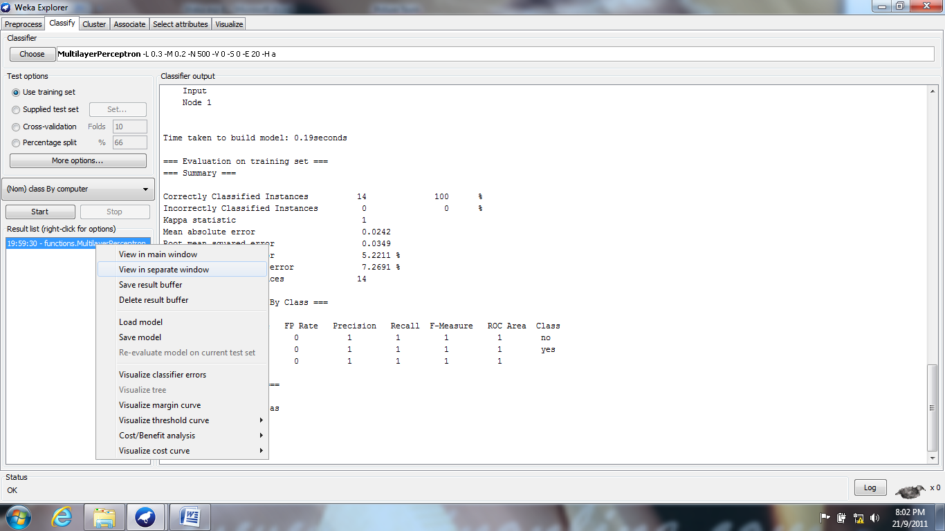

Fig- 5: Selecting The Option "View In Separate Window"

Finally the output is shown in a separate window is as follows:

=== Run information ===

Scheme: weka.classifiers.functions.MultilayerPerceptron -L 0.3 -M 0.2 -N 500 -V 0 -S 0 -E 20 -H a Relation: weka exp-4

Instances: 14

Attributes: 6

Customer ID

Age

Income   
Student

Credit Rating

Class by Computer

Test mode: evaluate on training data

=== Classifier model (full training set) ===

Sigmoid Node 0

Inputs Weights

Threshold 4.597303099925899

Node 2 -2.965811084944313

Node 3 -2.8207211391081324

Node 4 -2.5343621922785937

Node 5 -0.7092926749950742

Node 6 -3.202080364079574

Sigmoid Node 1

Inputs Weights

Threshold -4.590882027556084

Node 2 2.936363944100418

Node 3 2.8380779417219175

Node 4 2.5358725504279915

Node 5 0.6559016508925626

Node 6 3.230555090955558

Sigmoid Node 2

Inputs Weights

Threshold -0.08047245781235832

Attrib customer ID 0.22193220508213732

Attrib age=youth -1.5127951967716864

Attrib age=middle 1.8498200753538858

Attrib age=senior -0.3411353536325934

Attrib income=high -0.3203721986959815

Attrib income=medium 1.3074938148771482

Attrib income=low -0.9766407864775274

Attrib student 3.3163099912451774

Attrib credit rating -2.239705348709711

Sigmoid Node 3

Inputs Weights

Threshold -0.08606520678501425

Attrib customer ID 0.22787351339623643

Attrib age=youth -1.4568491246182191

Attrib age=middle 1.8065079530931696

Attrib age=senior -0.32844652534937113

Attrib income=high -0.3044507586834089

Attrib income=medium 1.2822518641711322

Attrib income=low -0.9331363251717437

Attrib student 3.210625483183134

Attrib credit rating -2.1592561505892798

Sigmoid Node 4

Inputs Weights

Threshold -0.10045745915917204

Attrib customer ID 0.2609258565067224

Attrib age=youth -1.3491882905571375

Attrib age=middle 1.7163298243001262

Attrib age=senior -0.29465813645261985

Attrib income=high -0.2787472175956876

Attrib income=medium 1.1737333812906028

Attrib income=low -0.8138256247222926

Attrib student 2.9167768340074973

Attrib credit rating -2.0180847298886704

Sigmoid Node 5

Inputs Weights

Threshold -0.4062972229764489

Attrib customer ID 0.23329558490703314

Attrib age=youth -0.24798044277287876

Attrib age=middle 1.1121334434039274

Attrib age=senior -0.3946052232908662

Attrib income=high 0.06310320479245372

Attrib income=medium 0.3546927981498891

Attrib income=low -0.010888839973622326

Attrib student 1.2539279626118915

Attrib credit rating -0.6857273386061201

Sigmoid Node 6

Inputs Weights

Threshold 2.693721030885051E-4

Attrib customer ID 0.2975412089953832

Attrib age=youth -1.586507555483025

Attrib age=middle 1.9784283043459296

Attrib age=senior -0.31868335584842467

Attrib income=high -0.32524337164708084

Attrib income=medium 1.368485717420782

Attrib income=low -1.0617305103863552

Attrib student 3.5359771210150868

Attrib credit rating -2.3960911468747335

Class no

Input

Node 0

Class yes

Input

Node 1

Time taken to build model: 0.19seconds

=== Evaluation on training set ===

=== Summary ===

Correctly Classified Instances 14 100 %

Incorrectly Classified Instances 0 0 %

Kappa statistic 1

Mean absolute error 0.0242

Root mean squared error 0.0349

Relative absolute error 5.2211 %

Root relative squared error 7.2691 %

Total Number of Instances 14

=== Detailed Accuracy by Class ===

TP Rate FP Rate Precision Recall F-Measure ROC Area Class

1 0 1 1 1 1 no

1 0 1 1 1 1 yes

Weighted Avg. 1 0 1 1 1 1

=== Confusion Matrix ===

a b <-- classified as

5 0 | a = no

0 9 | b = yes

**Output:** Results are displayed in the Test Output Window.

**Title 10: CLASSIFICATION USING NAÏVE BAYES CLASSIFIER**

**Aim**: Classification using Naïve Bayes Classifier

There is a necessity to provide a clear classification of data mining systems which may help users to distinguish between such systems and to identify them.

Data mining classification can be done in different ways:

* Data mining can be classified according to the kinds of databases mined.
* Data mining can be classified according to the kinds of knowledge mined which is done based on the mining functionalities like characterization, discrimination etc.
* We can also classify the data mining systems according to the kinds of techniques utilized, applications adapted.

**NaiveBayes:**

Classification of data can be carried out through by using Bayesian Theorems.

NaiveBayes classifier is a simple probabilistic classifier based on applying the Bayes theorem with strong independence assumptions based upon functions. It is classifier assumes that the presence or absence of a particular feature of a class is unrelated to the presence or absence of any other feature. The advantage of the NaiveBayes classifier is that, it only requires small amount of training data to estimate the parameters like mean, and variances of the variables necessary for classification.

**Procedure :**

Open the Weka GUI Chooser from start menu to all programs and to Weka 3.6.5 and click on Weka 3.6 and click the Explorer button on it.

Now open a file by clicking on the Open File button and choose the file named as “CANB.CSV” where the content of caviamlp.csv is as shown in the fig- 1.

|  |  |  |  |  |  |
| --- | --- | --- | --- | --- | --- |
| **Customer ID** | **Age** | **Income** | **Student** | **Credit Rating** | **Class by Computer** |
| 1 | Youth | High | No | Fair | No |
| 2 | Youth | High | No | Excellent | No |
| 3 | Middle | High | No | Fair | Yes |
| 4 | Senior | Medium | No | Fair | Yes |
| 5 | Senior | Low | Yes | Fair | Yes |
| 6 | Senior | Low | Yes | Excellent | No |
| 7 | Middle | Low | Yes | Excellent | Yes |
| 8 | Youth | Medium | No | Fair | No |
| 9 | Youth | Low | Yes | Fair | Yes |
| 10 | Senior | Medium | Yes | Fair | Yes |
| 11 | Youth | Medium | Yes | Excellent | Yes |
| 12 | Middle | Medium | No | Excellent | Yes |
| 13 | Middle | High | Yes | Fair | Yes |
| 14 | Senior | Medium | No | Excellent | No |

Fig- 1: Input File (CANB.CSV)

Loading the input file into the explorer to perform the classification as shown in the below fig- 2.



Fig- 2: Load The File CANB.CSV

After loading the input file named canb.csv as shown in fig- 2, choose the classify tab in the WEKA explorer window. Under the classify tab click on choose button and select the NaiveBayes under Bayes as shown in the following fig- 3.

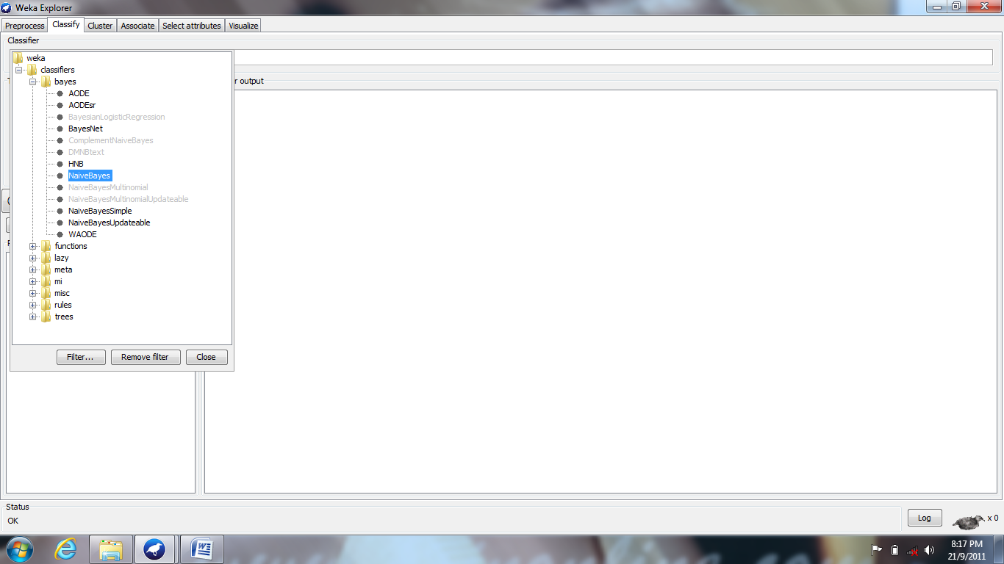

**Fig-3: Selecting The NaiveBayes**

Select the “use training set “under the Test Options located at the left of the weka explorer window and click on start button. The output is represented in the Classifier Output window in weka explorer window, which is as shown in fig- 4 below:

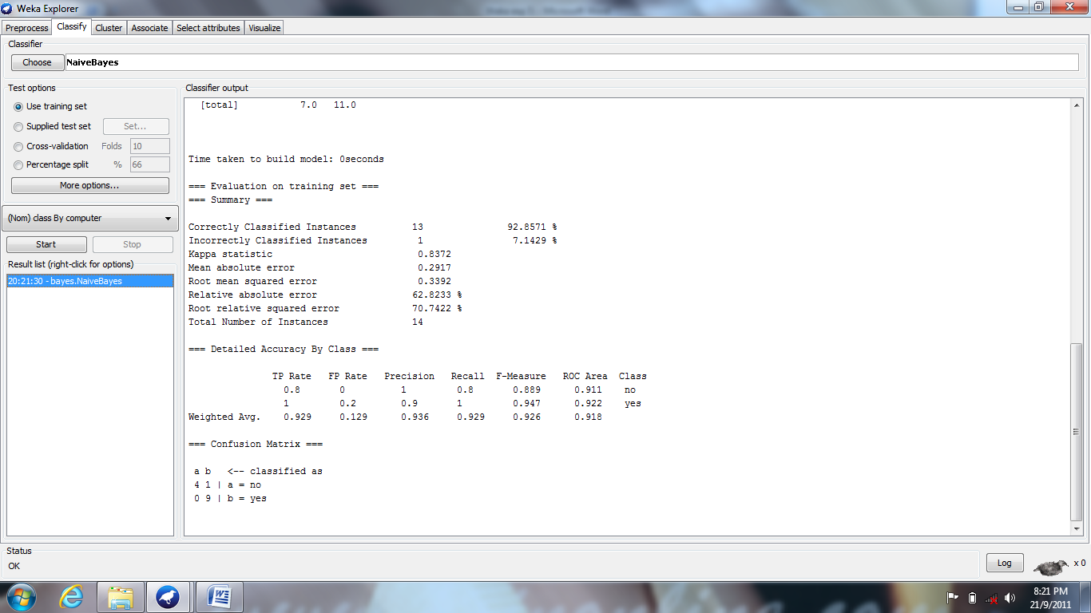

**Fig- 4: Showing Output In Classifier Output Window In Weka Explorer Window**

Now we are able to view the output in a separate window by right clicking on the option in result list and clicking on “view in separate window” as shown in fig- 5.

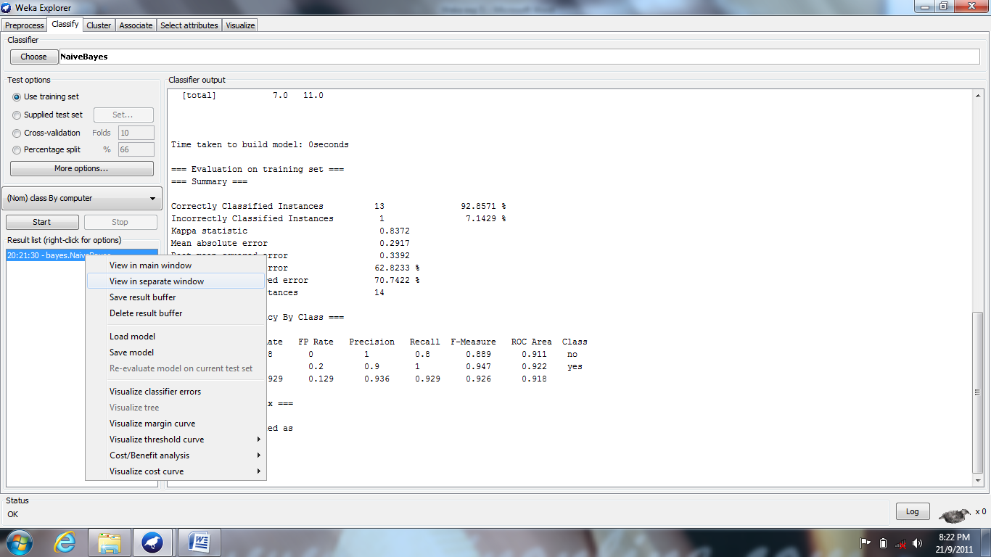

Fig- 5: Selecting The Option "View In Separate Window"

Finally the output is shown in a separate window is as follows:

=== Run information ===

Scheme:weka.classifiers.bayes.NaiveBayes Relation: classify

Instances: 14   
Attributes: 5

Age

Income   
Student

Credit rating

Class by computer

Test mode:evaluate on training data

=== Classifier model (full training set) ===

Naive Bayes Classifier

Class

Attribute no yes

(0.38) (0.63)

==============================

age

youth 4.0 3.0

middle 1.0 5.0

senior 3.0 4.0

[total] 8.0 12.0

income

high 3.0 3.0

medium 3.0 5.0

low 2.0 4.0

[total] 8.0 12.0

student

no 5.0 4.0

yes 2.0 7.0

[total] 7.0 11.0

credit rating

fair 3.0 7.0

excellent 4.0 4.0

[total] 7.0 11.0

Time taken to build model: 0seconds

=== Evaluation on training set ===

=== Summary ===

Correctly Classified Instances 13 92.8571 %

Incorrectly Classified Instances 1 7.1429 %

Kappa statistic 0.8372

Mean absolute error 0.2917

Root mean squared error 0.3392

Relative absolute error 62.8233 %

Root relative squared error 70.7422 %

Total Number of Instances 14

=== Detailed Accuracy By Class ===

TP Rate FP Rate Precision Recall F-Measure ROC Area Class

0.8 0 1 0.8 0.889 0.911 no

1 0.2 0.9 1 0.947 0.922 yes

Weighted Avg. 0.929 0.129 0.936 0.929 0.926 0.918

=== Confusion Matrix ===

a b <-- classified as

4 1 | a = no

**Output:** Results are displayed in the Test Output Window.

**Title 11: EVALUATING THE PERFORMANCE OF IBK CLASSIFIER**

**Aim:** To evaluate the IBK Classifier Performance of training set and test set. Apply the Gain Ratio, Attribute Evaluator method and ranker method of attribute selection using knowledge flow.

**Components Used:**

|  |  |  |
| --- | --- | --- |
| Name of the icon | Tab | Purpose |
| ArffLoader | DataSources | To choose the dataset |
| ClassAssigner | Evaluation | Class chosen to be carried to the next step |
| TrainingSetMaker | Evaluation | Chosen for Preprocessing from the existing dataset |
| Test Set Maker | Evaluation | A test data is chosen from the selected data set. |
| Attribute Selection | Filters | Used to select attribute using an evaluation and rank method |
| IBK | Classifier | Classification based on Lazy Learners. |
| ClassifierPerformanceEvaluator | Evaluation | To test the performance of two different datasets of data which is applied and classified |
| Text viewer | Visualization | Shows the result of classification after loading the data and shows the result in current working area. |

**Procedure:** The arrangement and linking of icons for ‘Training set and test set’

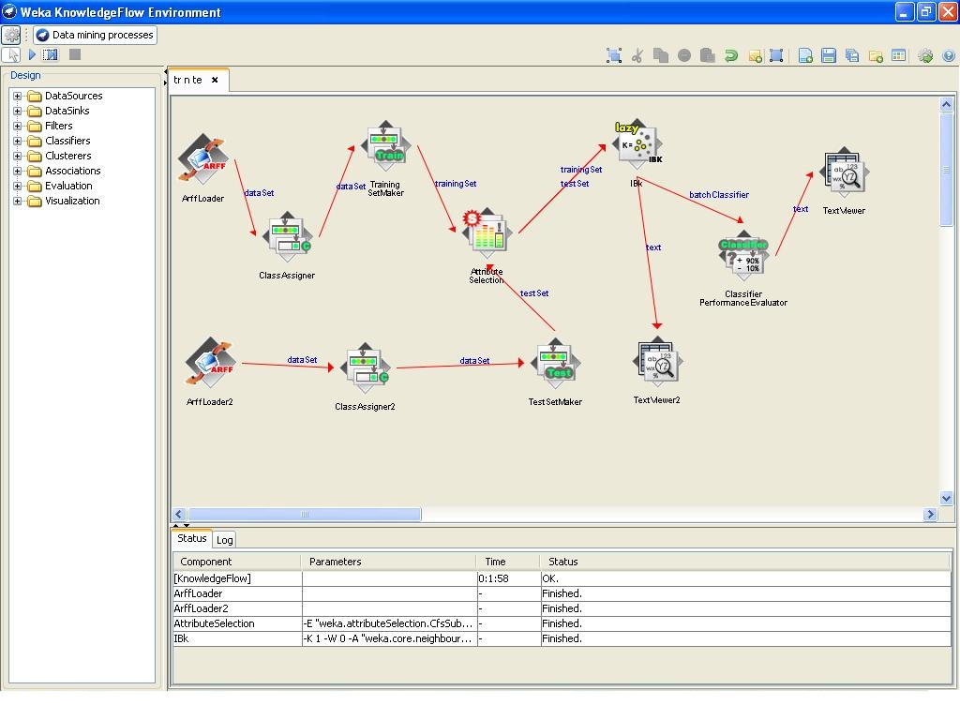

After the run’finished‘ without ‘interrupts‘;

right click over the text viewer2 icon by clicking on ‘show results’

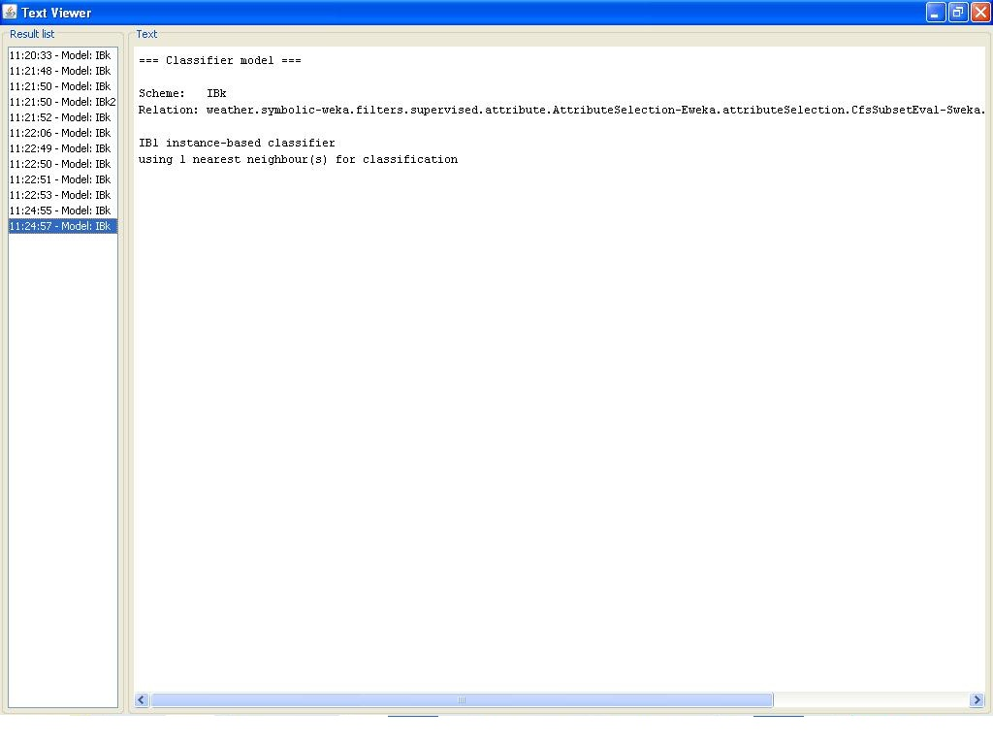

**On text viewer1**

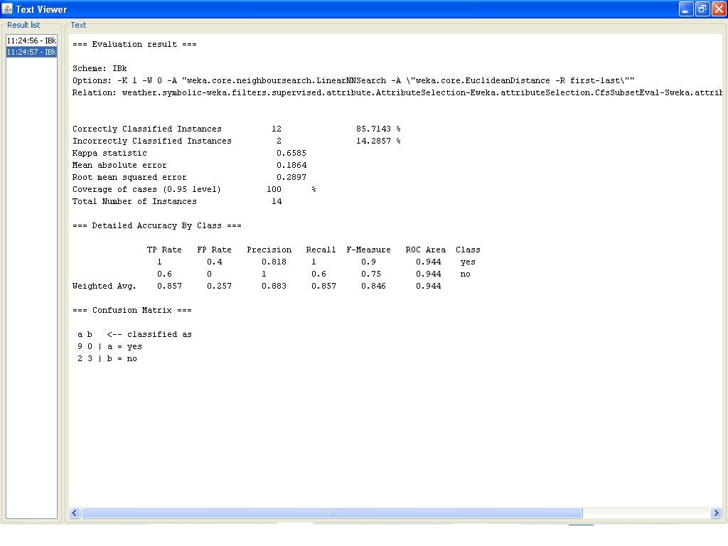

**Output:** Results are displayed in text viewer windows**.**

**Title 12: CLUSTERING**

**Aim:** Clustering using k-means algorithm

Clustering is a task of assigning a set of objects into groups called as clusters. Clustering is also referred as cluster analysis where the objects in the same cluster are more similar to each other than to those objects in other clusters.

It is the main task of Explorative Data mining and is a common technique for statistical data analysis used in many fields like machine learning, pattern recognition, image analysis, bio informatics etc.

Cluster analysis is not an algorithm but is a general task to be solved.

It is of different types like hierarchical clustering which creates a hierarchy of clusters, partial clustering, and spectral clustering.

**SimpleK-Means:**

Simple K-Means is a method of cluster analysis called as partial cluster analysis or partial clustering. K-Means clustering partition or divides n observations into K clusters. Each observation belongs to the cluster with the nearest mean.

K-means clustering is an algorithm to group the objects based on attributes/features into K number of groups where K is positive integer. Which is used in different types of applications like pattern recognition, artificial intelligent, image processing etc.

**Procedure:**

Open the Weka GUI Chooser from start menu to all programs and to Weka 3.6.5 and click on Weka 3.6 and click the Explorer button on it.

Now open a file by clicking on the Open File button and choose the file named as “CLUSTERING.CSV” where the content of caviamlp.csv is as shown in the fig- 1.

|  |  |  |  |  |  |
| --- | --- | --- | --- | --- | --- |
| **Customer ID** | **Age** | **Income** | **Student** | **Credit Rating** | **Class by Computer** |
| 1 | Youth | High | No | Fair | No |
| 2 | Youth | High | No | Excellent | No |
| 3 | Middle | High | No | Fair | Yes |
| 4 | Senior | Medium | No | Fair | Yes |
| 5 | Senior | Low | Yes | Fair | Yes |
| 6 | Senior | Low | Yes | Excellent | No |
| 7 | Middle | Low | Yes | Excellent | Yes |
| 8 | Youth | Medium | No | Fair | No |
| 9 | Youth | Low | Yes | Fair | Yes |
| 10 | Senior | Medium | Yes | Fair | Yes |
| 11 | Youth | Medium | Yes | Excellent | Yes |
| 12 | Middle | Medium | No | Excellent | Yes |
| 13 | Middle | High | Yes | Fair | Yes |
| 14 | Senior | Medium | No | Excellent | No |

Fig- 1: Input File (CLUSTERING.CSV)

Loading the input file into the explorer to perform the Clustering as shown in the below fig- 2.



Fig- 2: Load The File CLUSTERING.CSV

After loading the input file named cluster.csv as shown in fig- 2, choose the cluster tab in the WEKA explorer window. Under the cluster tab click on choose button and select the SimpleKMeans under clusterers as shown in the following fig- 3.

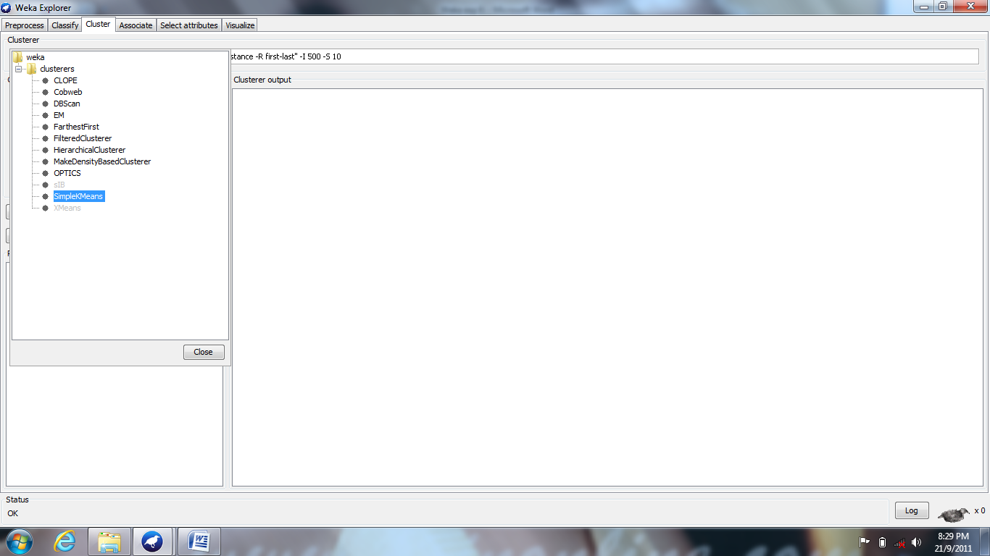

**Fig-3: Selecting The SimpleKMeans**

Select the “use training set” under the Test Options located at the left of the Weka explorer window and click on start button. The output is represented in the Cluster Output window in weka explorer window, which is as shown in fig- 4 below:

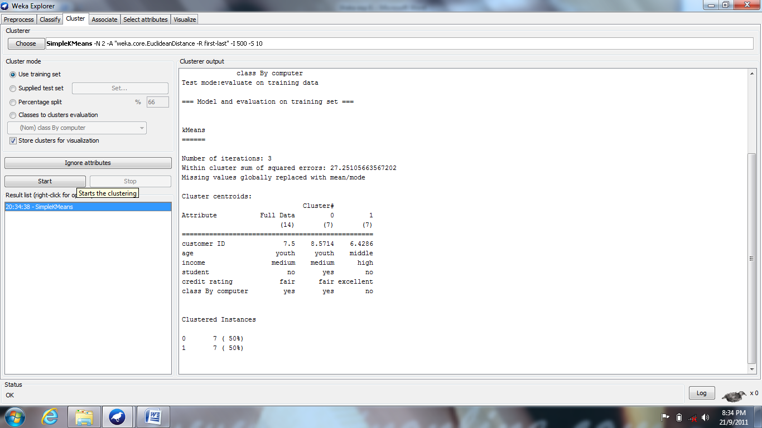

Fig- 4: Showing Output In Classifier Output Window In Weka Explorer Window

Now we are able to view the output in a separate window by right clicking on the option in result list and clicking on “view in separate window” as shown in fig- 5.

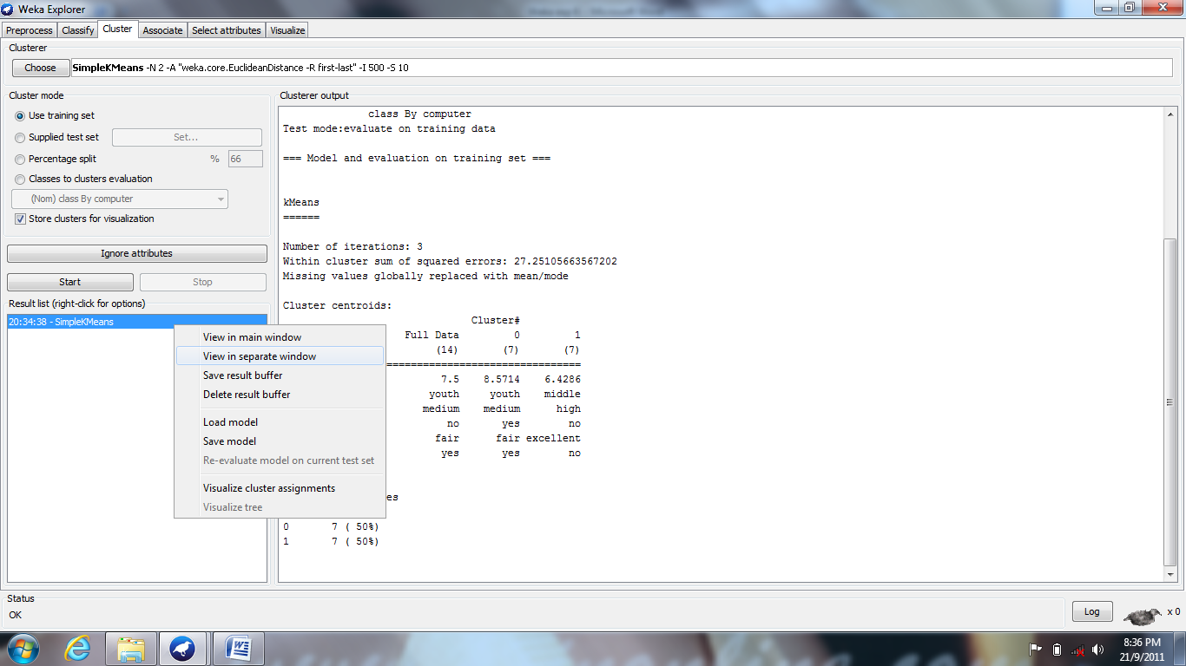

**Fig- 5: Selecting The Option "View In Separate Window"**

Finally the output is shown in a separate window is as follows:

=== Run information ===

Scheme:weka.clusterers.SimpleKMeans -N 2 -A "weka.core.EuclideanDistance -R first-last" -I 500 -S 10

Relation: weka exp-4

Instances:14

Attributes:6

Customer ID

Age

Income

Student

Credit rating

Class by computer

Test mode:evaluate on training data

=== Model and evaluation on training set ===

kMeans

======

Number of iterations: 3

Within cluster sum of squared errors: 27.25105663567202

Missing values globally replaced with mean/mode

Cluster centroids:

Cluster#

Attribute Full Data 0 1

(14) (7) (7)

=================================================

Customer ID 7.5 8.5714 6.4286

Age youth youth middle

Income medium medium high

Student no yes no

Credit rating fair fair excellent

Class by computer yes yes no

Clustered Instances

0 7 ( 50%)

1 7 ( 50%)

**Output:** Results are displayed in the Test Output Window.

**Title 13 : ASSOCIATION RULES GENERATION**

**Aim:** Association Rule Generation using Apriori

Association is a very popular method for discovering interesting relations between variables in large databases. It is used to identify the most frequent item sets or frequent patterns that occur frequently in a database.

We need two parameters to perform association rule mining like:

1. **Support:** It is the total probability of the item sets that occurred in the transaction.
2. **Confidence:** It is the ratio of probability of two item sets A, B and the probability of the item set A.

Association rule mining is used in different applications like basket analysis, catalog design, clustering, classification etc.

**Apriori Algorithm:**

To implement the association rule we use this algorithm.

Steps to follow while implementing the association rule are:

* Find the frequent item sets where the items have the minimum support count.
* Use the frequent item sets to generate association rules.
* Generate the candidates by performing join operation.
* Perform pruning operation i.e. if any one of the candidates that have a subset is not frequent in the set then delete it.
* Also calculate support count for each candidate and delete those candidates whose minimum support count is not satisfied.

**Procedure:**

Open the Weka GUI Chooser from start menu to all programs and to Weka 3.6.5 and click on Weka 3.6 and click the Explorer button on it.

Now open a file by clicking on the Open File button and choose the file named as “CAMLP.CSV” where the content of caviamlp.csv is as shown in the fig- 1.

|  |  |
| --- | --- |
| Trans. ID | Item List |
| T1 | i1, i2, i5 |
| T2 | i2, i4 |
| T3 | i2, i3 |
| T4 | i1, i2, i4 |
| T5 | i1, i3 |
| T6 | i2, i3 |
| T7 | i1, i3 |
| T8 | i1, i2, i3, i5 |
| T9 | i1, i2, i3 |

**Fig- 1: Input File (ASSOCIATION.CSV)**

Loading the input file into the explorer to perform the association as shown in the below fig- 2.

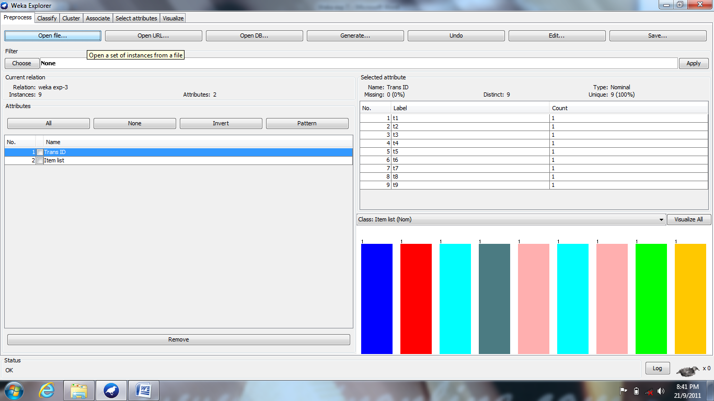

Fig- 2: Load The File ASSOCIATION.CSV

After loading the input file named association.csv as shown in fig- 2, choose the associate tab in the Weka explorer window. Under the associate tab click on choose button and select the Apriori Algorithm under associations as shown in the following fig- 3.

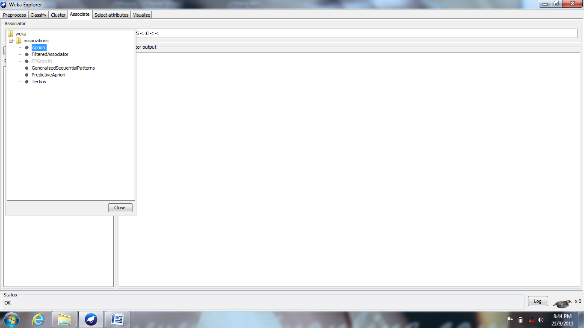

Fig- 3: Selecting The Apriori Algorithm

Select the “use training set” under the Test Options located at the left of the weka explorer window and click on start button. The output is represented in the Association Output window in weka explorer window, which is as shown in fig- 4 below:

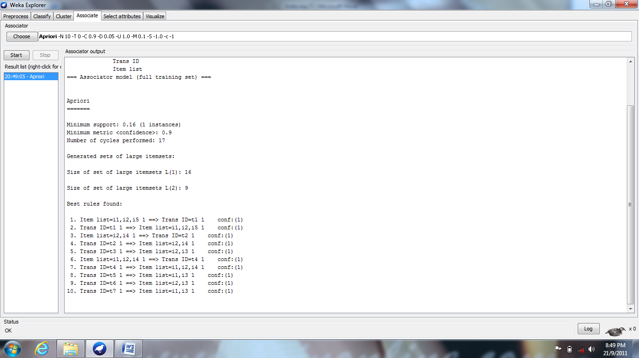

Fig- 4: Showing Output In Classifier Output Window In Weka Explorer Window

Now we are able to view the output in a separate window by right clicking on the option in result list and clicking on “view in separate window” as shown in fig- 5.

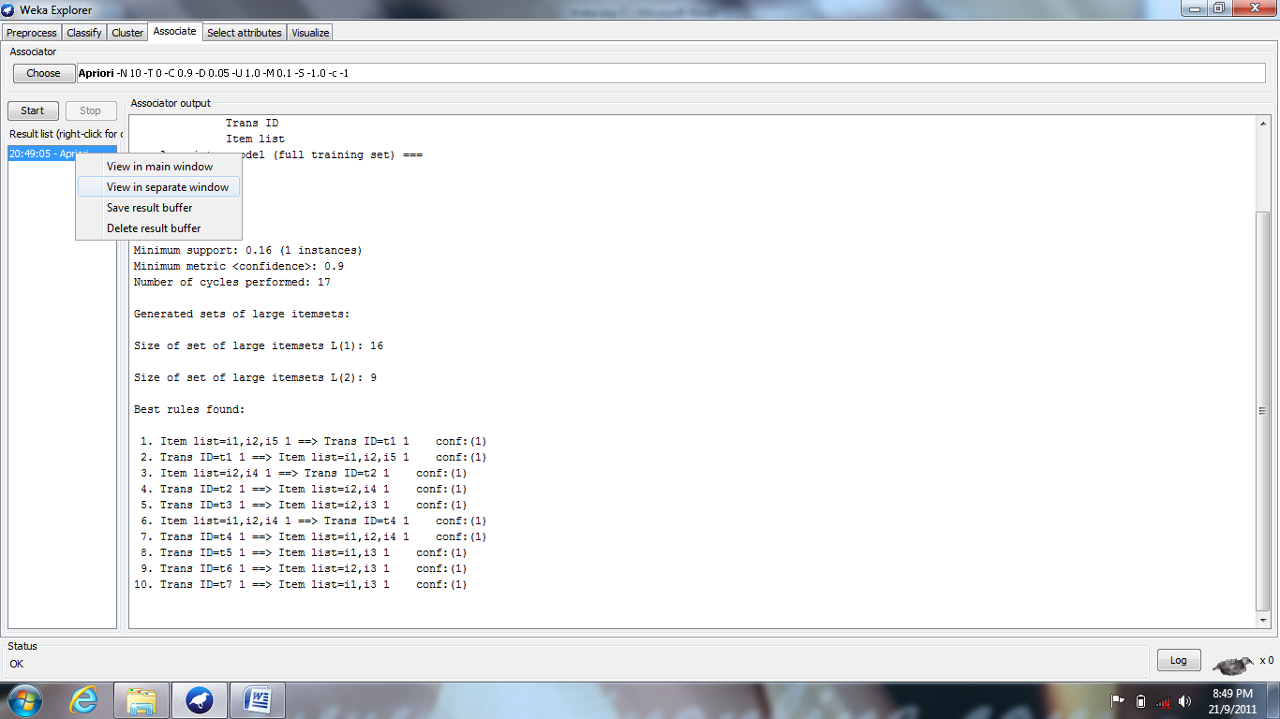

Fig- 5: Selecting The Option "View In Separate Window"

Finally the output is shown in a separate window is as follows:

=== Run information ===

Scheme: weka.associations.Apriori -N 10 -T 0 -C 0.9 -D 0.05 -U 1.0 -M 0.1 -S -1.0 -c -1

Relation: weka exp-3

Instances: 9

Attributes: 2

Trans. ID

Item List

=== Associator model (full training set) ===

Apriori

=======

Minimum support: 0.16 (1 instances)

Minimum metric <confidence>: 0.9

Number of cycles performed: 17

Generated sets of large itemsets:

Size of set of large itemsets L (1): 16

Size of set of large itemsets L (2): 9

Best rules found:

1. Item list=i1,i2,i5 1 ==> Trans ID=t1 1 conf:(1)

2. Trans ID=t1 1 ==> Item list=i1,i2,i5 1 conf:(1)

3. Item list=i2,i4 1 ==> Trans ID=t2 1 conf:(1)

4. Trans ID=t2 1 ==> Item list=i2,i4 1 conf:(1)

5. Trans ID=t3 1 ==> Item list=i2,i3 1 conf:(1)

6. Item list=i1,i2,i4 1 ==> Trans ID=t4 1 conf:(1)

7. Trans ID=t4 1 ==> Item list=i1,i2,i4 1 conf:(1)

8. Trans ID=t5 1 ==> Item list=i1,i3 1 conf:(1)

9. Trans ID=t6 1 ==> Item list=i2,i3 1 conf:(1)

10. Trans ID=t7 1 ==> Item list=i1,i3 1 conf:(1)

**Output:** Results are displayed in the Test Output Window.

**14 : DATA DISCRETIZATION – TO CONVERT NUMERIC DATA TO CATEGORICAL**

**Aim:** To discretize numeric attributes.

**Problem Definition:**

Association analysis can be performed only on categorical data. This requires performing discretization on numeric or continuous attributes.

**METHOD 1: MANUALLY**

We obtain the below format by right click over the **ARFF** file chosen

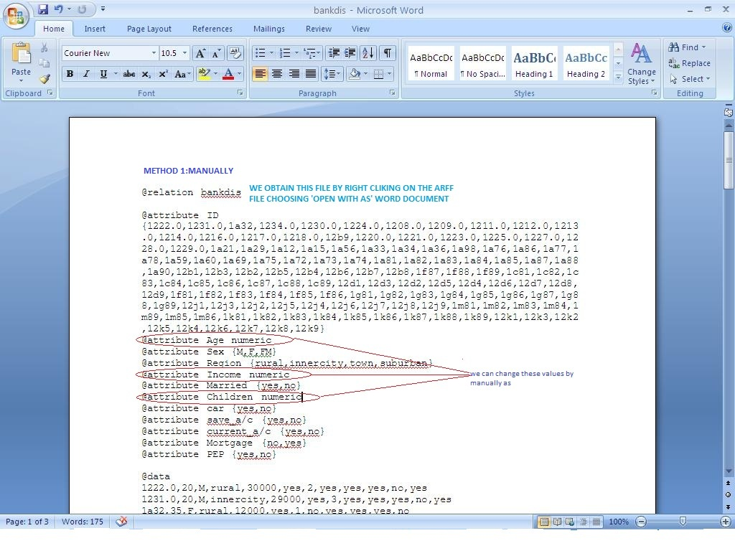

After Discretization i.e., changing the numeric attributes to nominal as by giving the indices for numeric attributes.

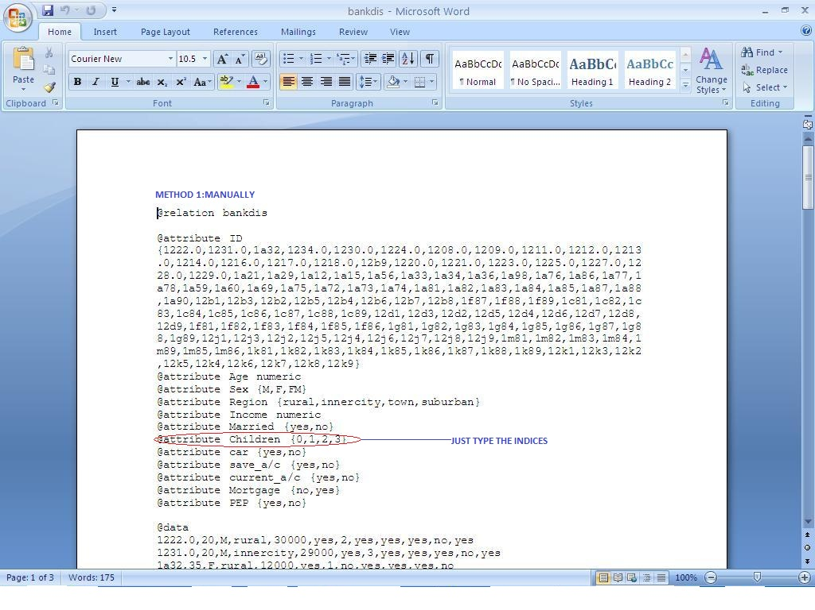

**METHOD 2: CHOOSE DISCRETIZE FILTER;** load the file usually watch the below fig

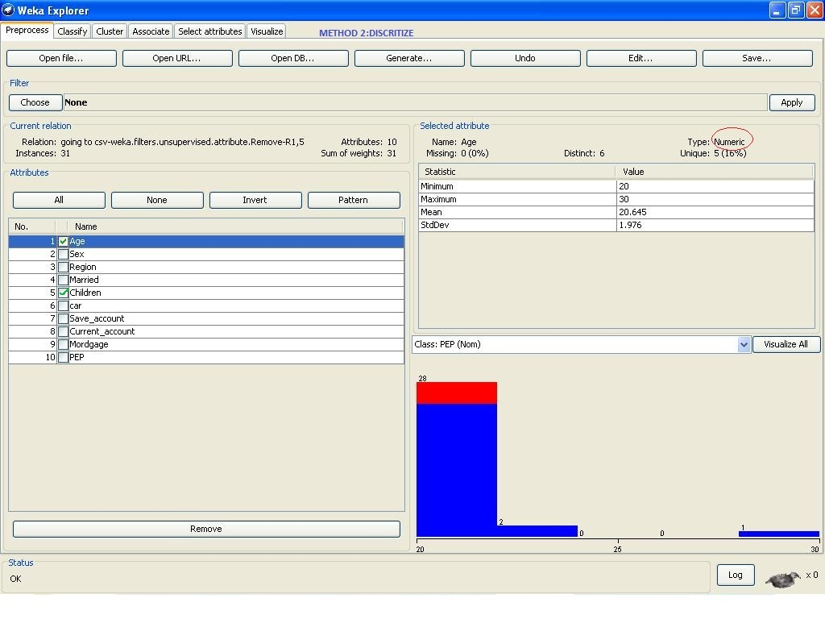

**Choosing discretize filter**

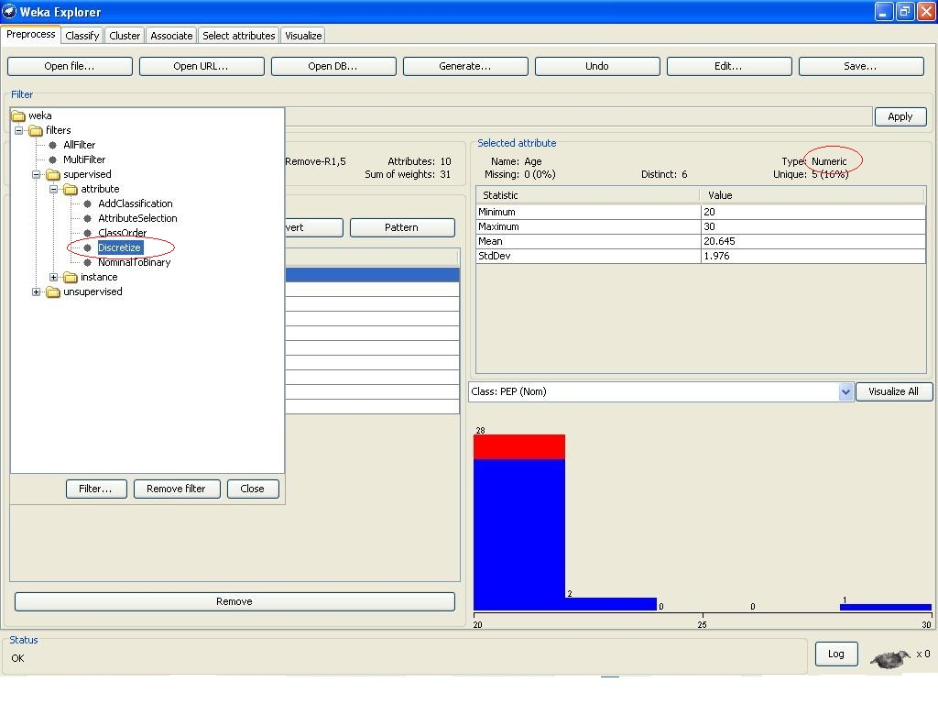

**After Discretization, the numeric type will be changed to nominal**

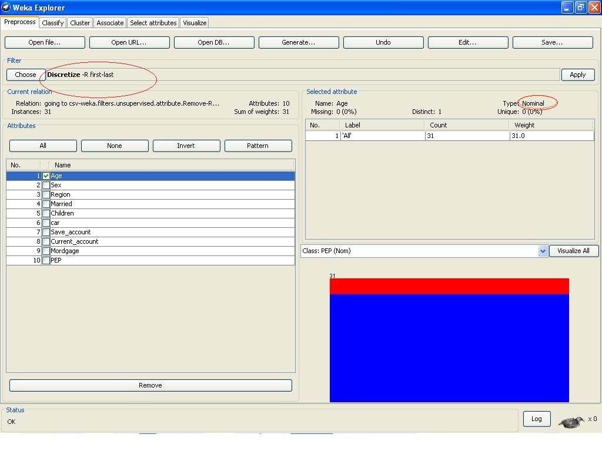

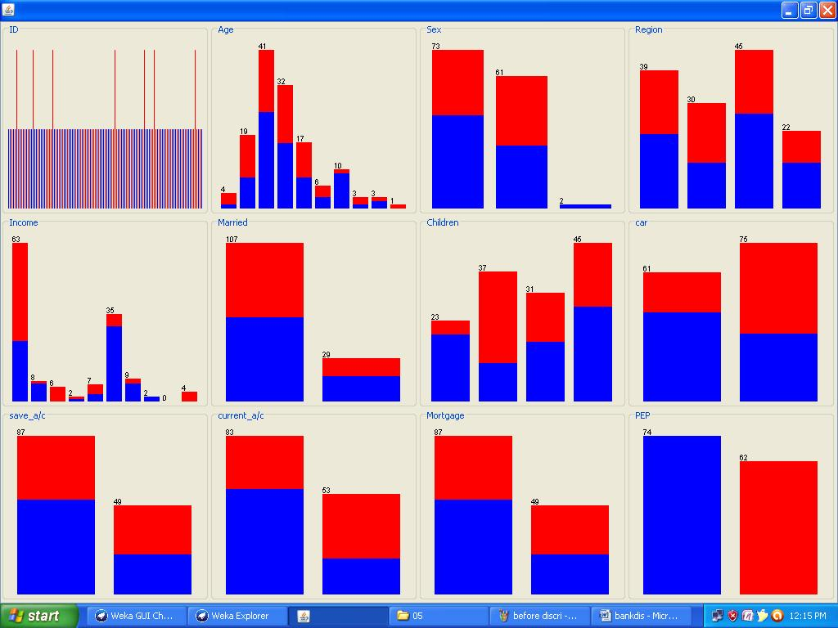

**Output:** Discretization of numeric to nominal was done successfully.

**15 : WEKA EXPERIMENT ENVIRONMENT USING SIMPLE MODE**

**Aim:** Using Weka Experiment Environment in Simple mode.

Problem Definition:

Allows standard experiments that are run locally on a simple machine or remote modeling that are distributed over several hosts.

**Procedure:**

**‘WEKA EXPERIMENT ENVIRONMENT’ LOOKS LIKE**

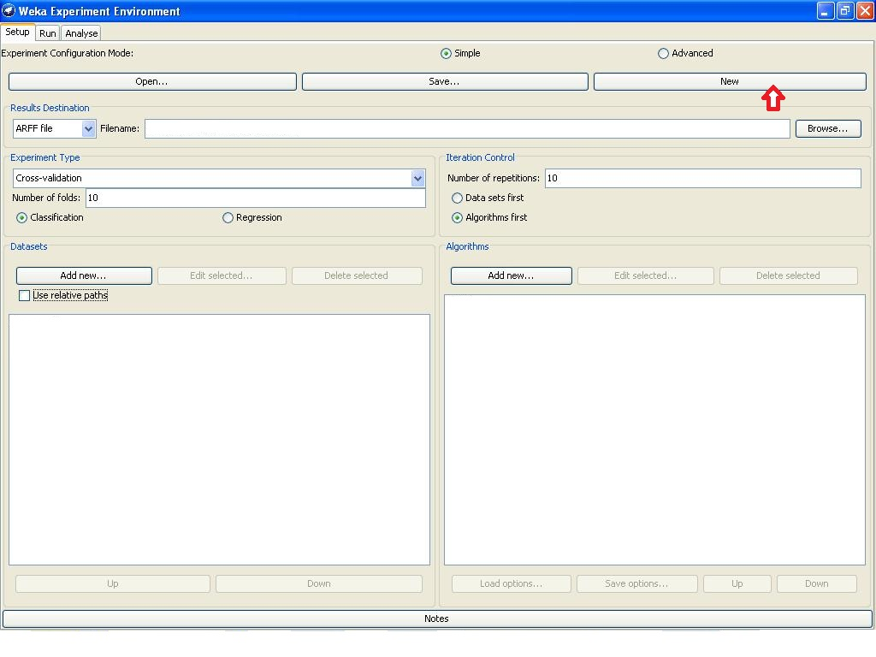

After pressing the ’new’ tab the window looks like above; now load the file by ‘Browse’ option;

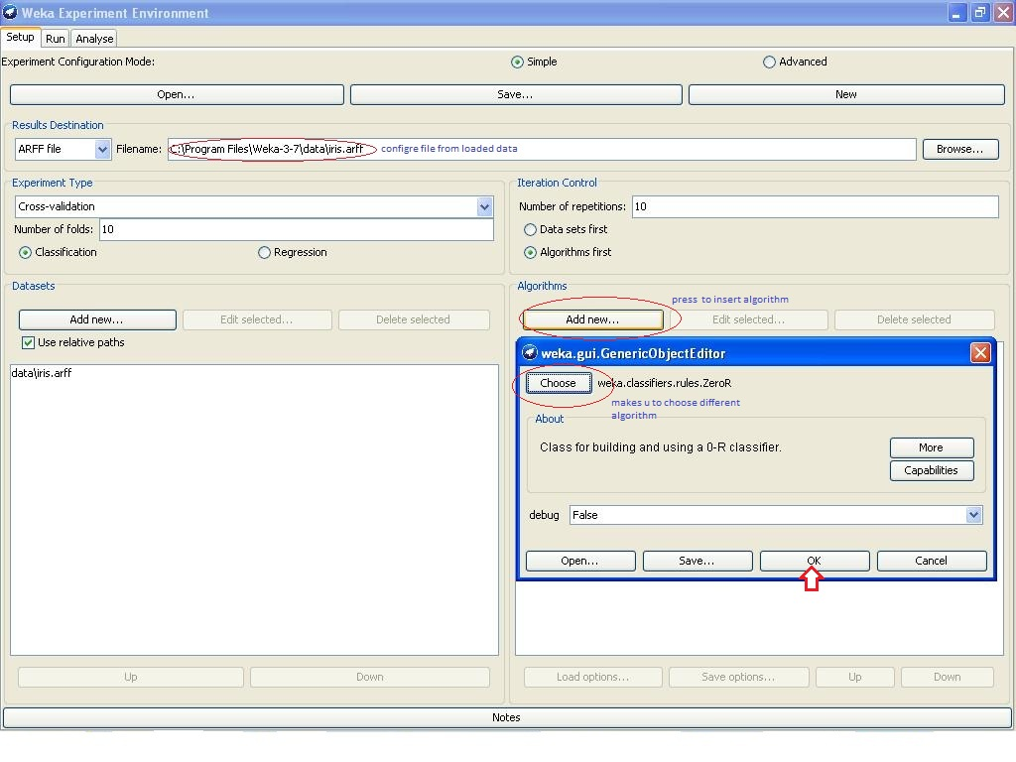

After pressing the ‘ok’ the algorithm chosen will be loaded; now skip to next menu table, RUN, to run loaded file

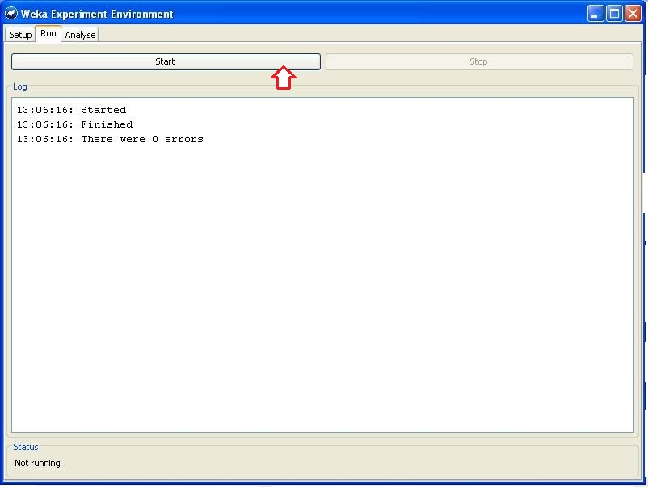

The messages should be compulsory executed, then we can ‘analyze’ results;

Press ‘experiment’ tab and then ‘perform’

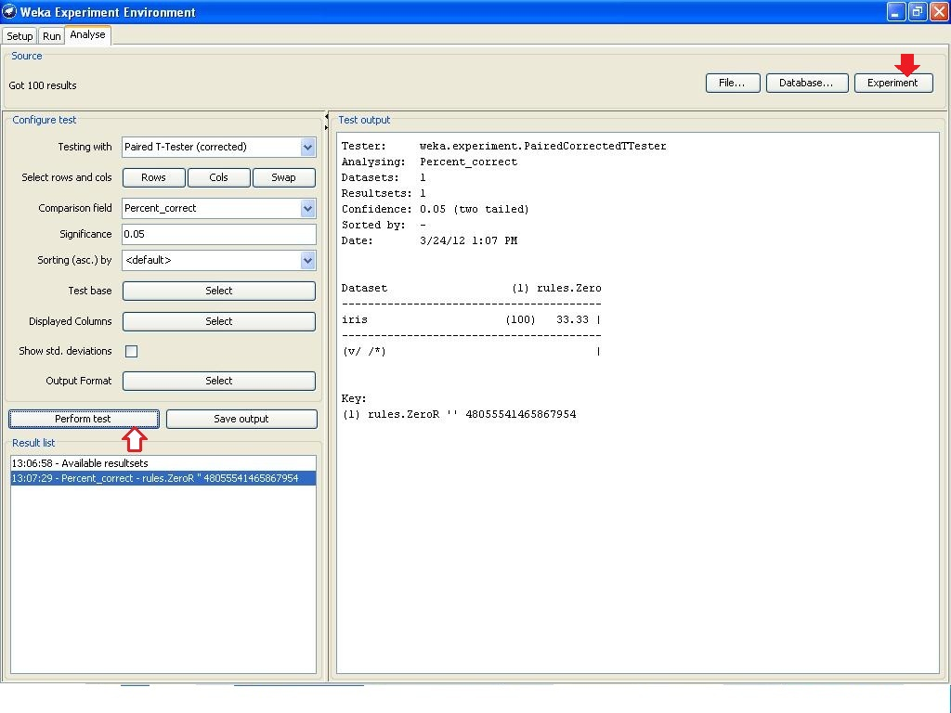

**Output:**  Results are displayed in the Test Output Window.